**Deploying a project in TOMCAT SERVER**

1. Use repo <https://github.com/akshu20791/testappfortomcatdeployment>

(Name: testappfortomcatdeployment)

1. Download git for windows
2. Download java 11
3. Download [32-bit/64-bit Windows Service Installer](https://dlcdn.apache.org/tomcat/tomcat-9/v9.0.64/bin/apache-tomcat-9.0.64.exe)

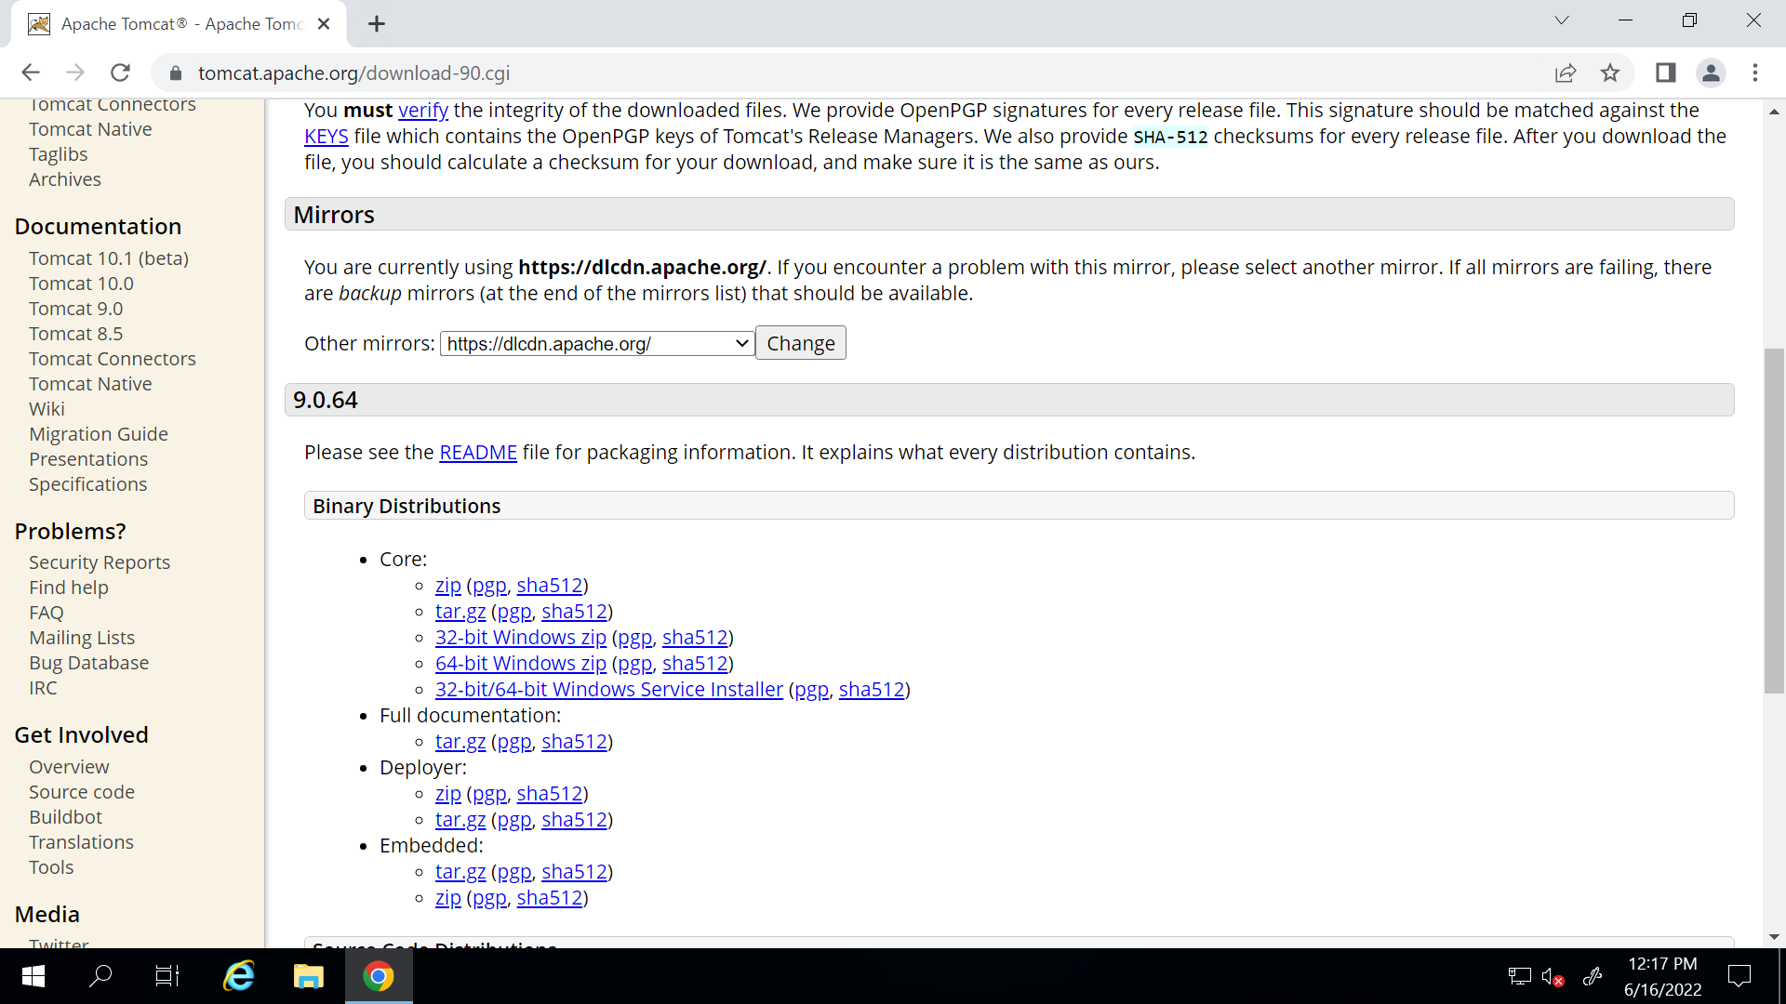

1. Download ant https://ant.apache.org/bindownload.cgi

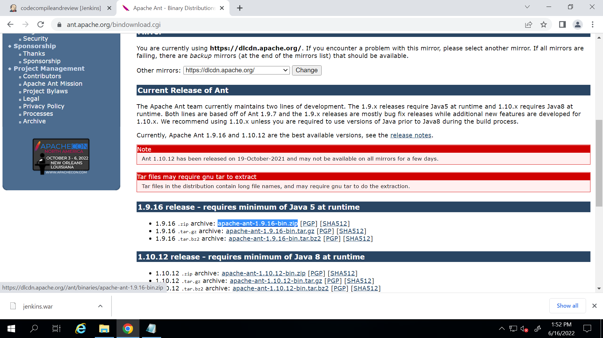



Now copy paste the zip folder in C drive

Now go to environment variables -> ANT_HOME and path

And also set the path to bin file

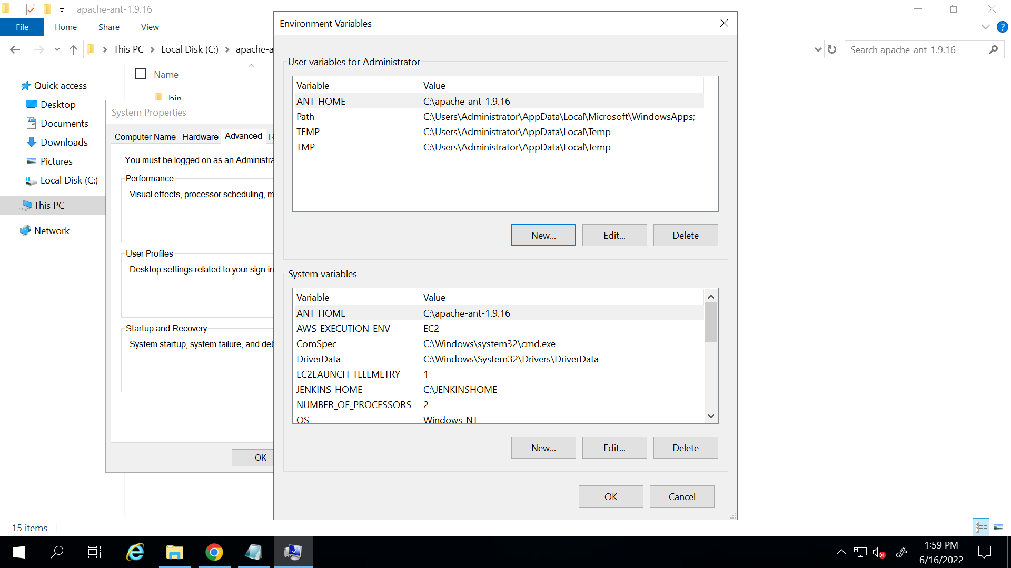

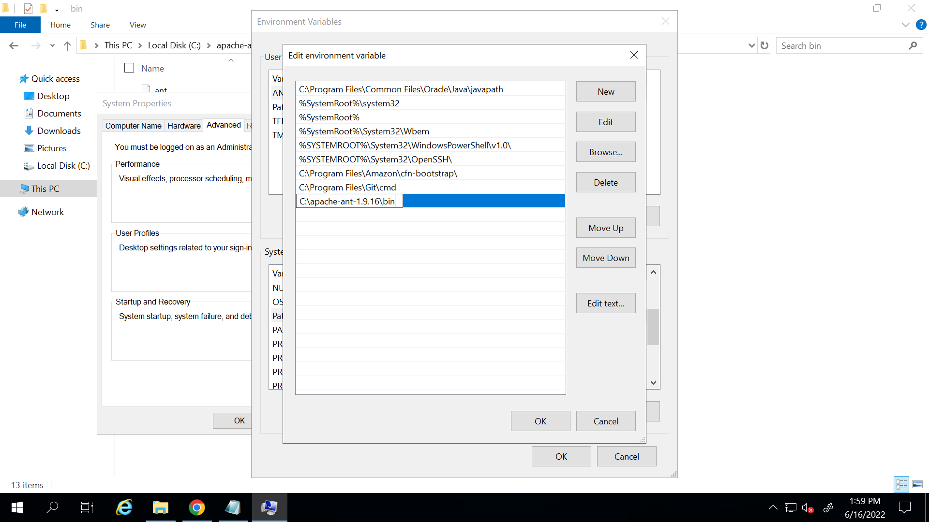

1. Search monitor tomcat and stop and start it again..also stop Jenkins and start again
2. User: admin

Pass: admin

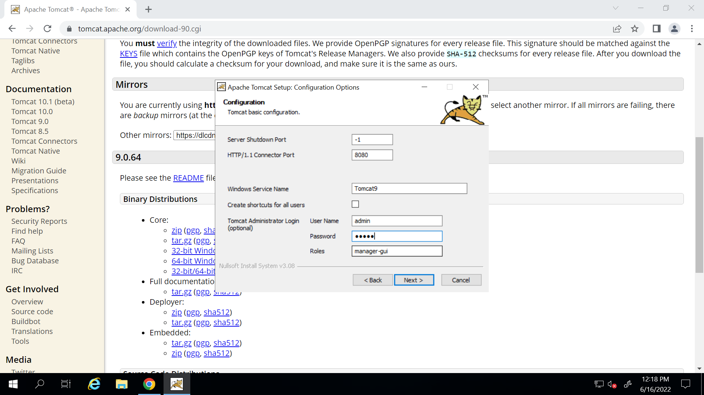

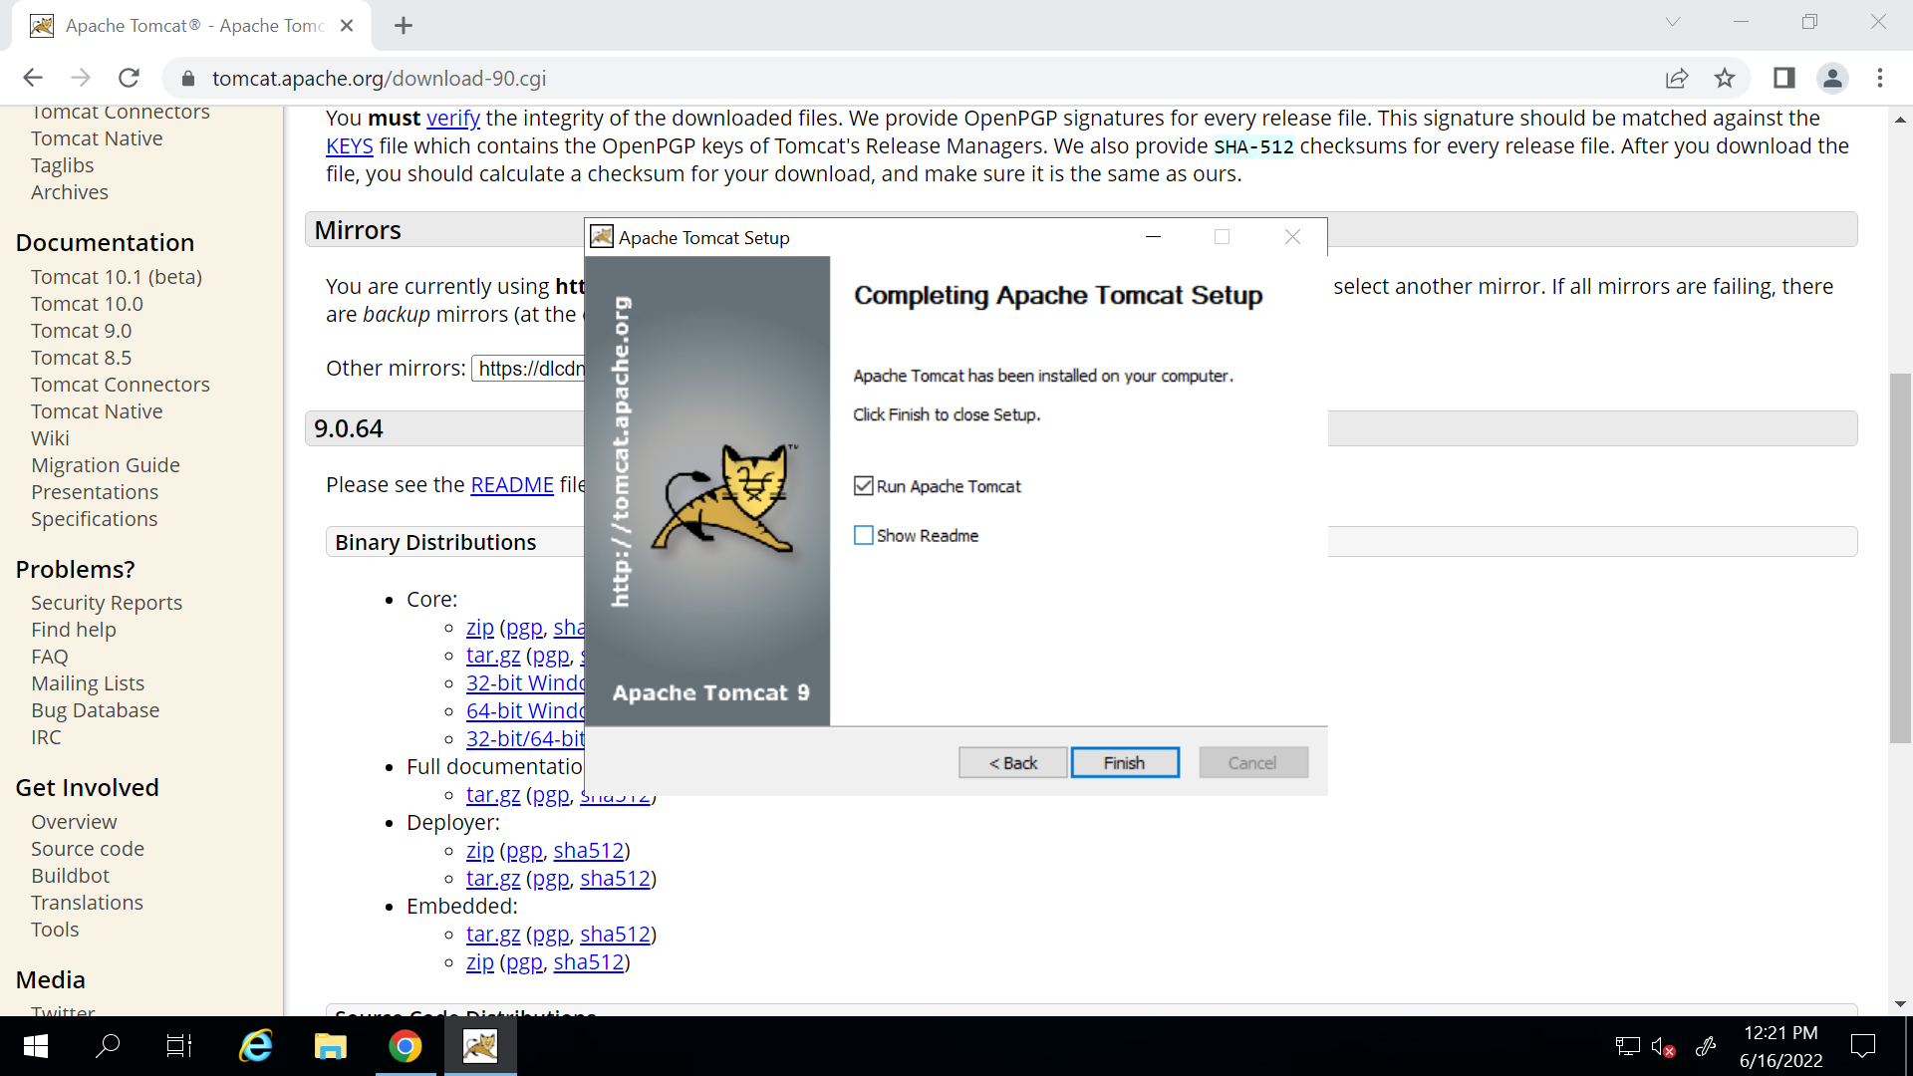

1. Go to Jenkins and download jenric war file

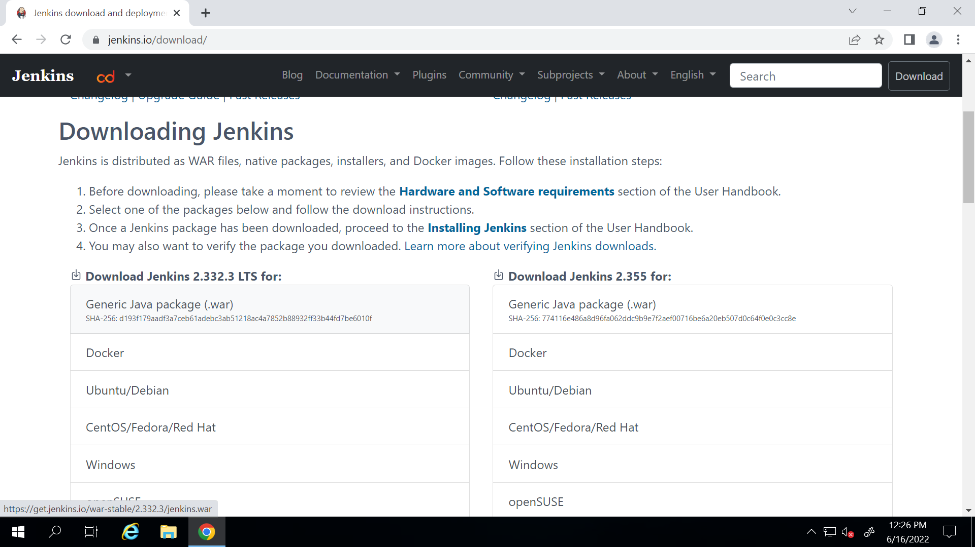

1. Search for monitor tomcat

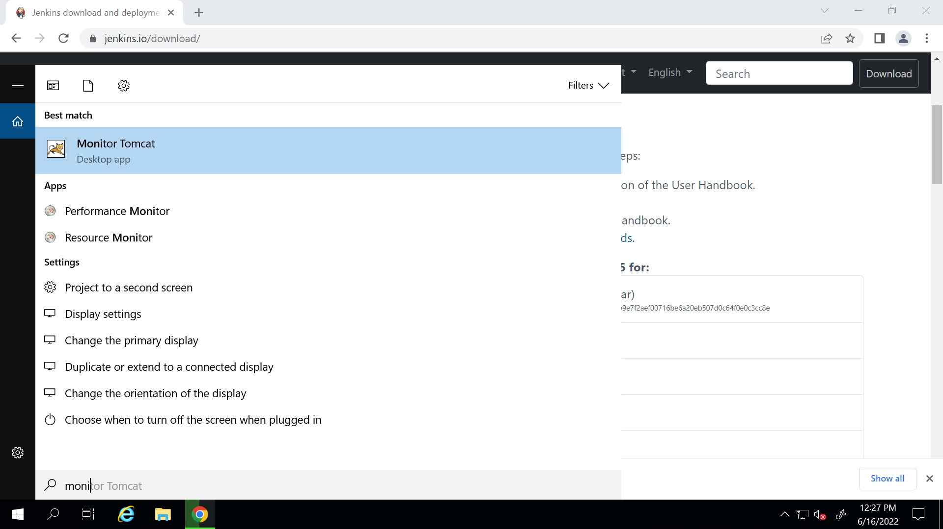

1. In browser open <http://localhost:8080/>

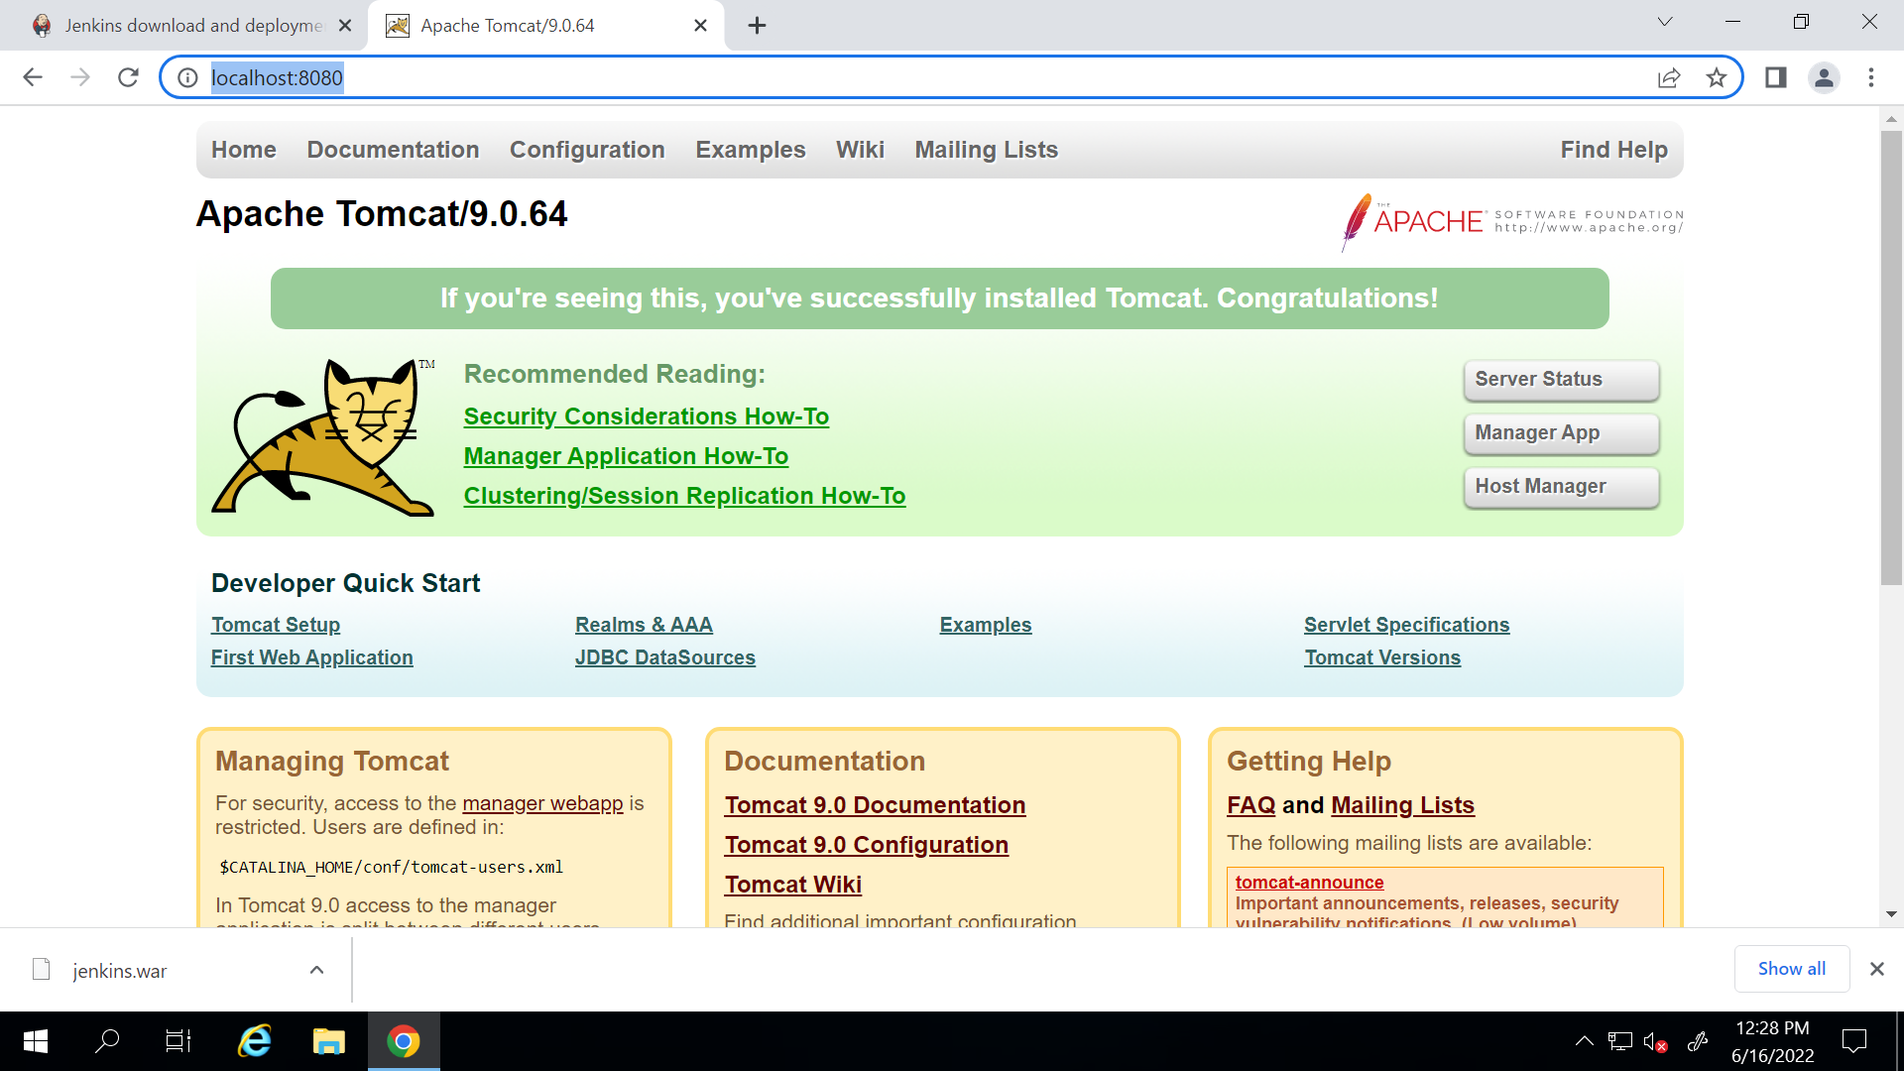

Click on manager app

Set user name and pass (admin and admin)

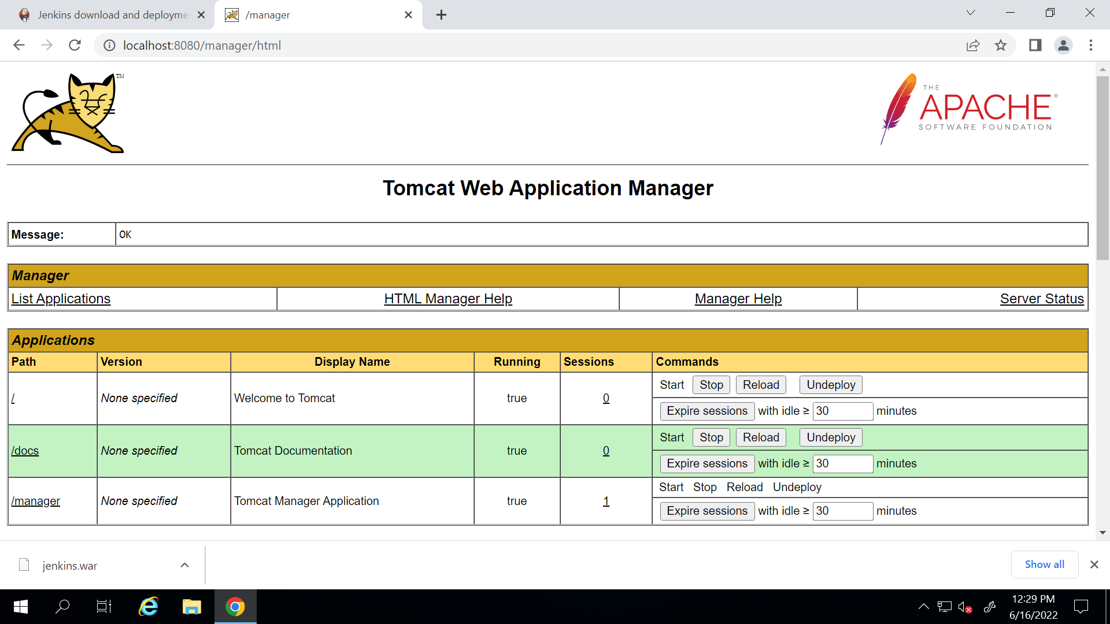

1. Now copy the Jenkins.war file and paste in C:\Program Files\Apache Software Foundation\Tomcat 9.0\webapps

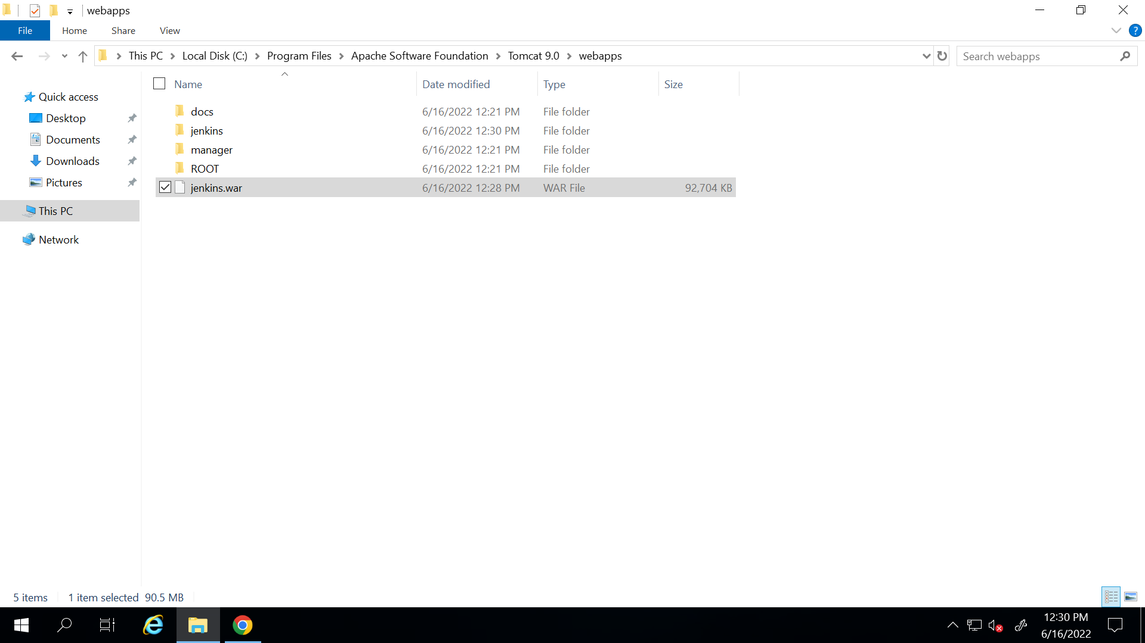

1. Go to monitor tomcat and stop and start it again . and when you will refresh the page you will see Jenkins

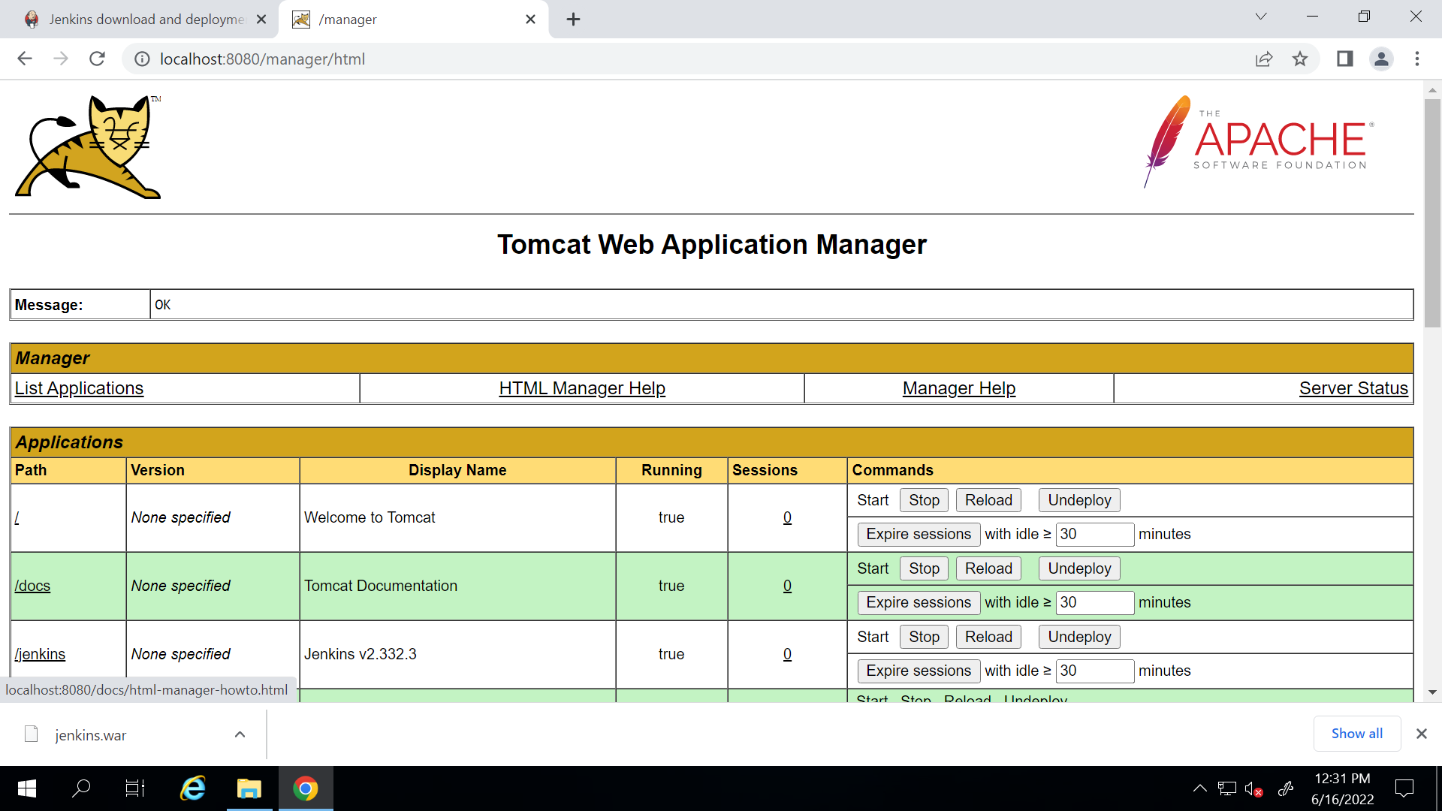

1. When you open the link <http://localhost:8080/jenkins/> you will open Jenkins
2. Now the Jenkins password link will not work

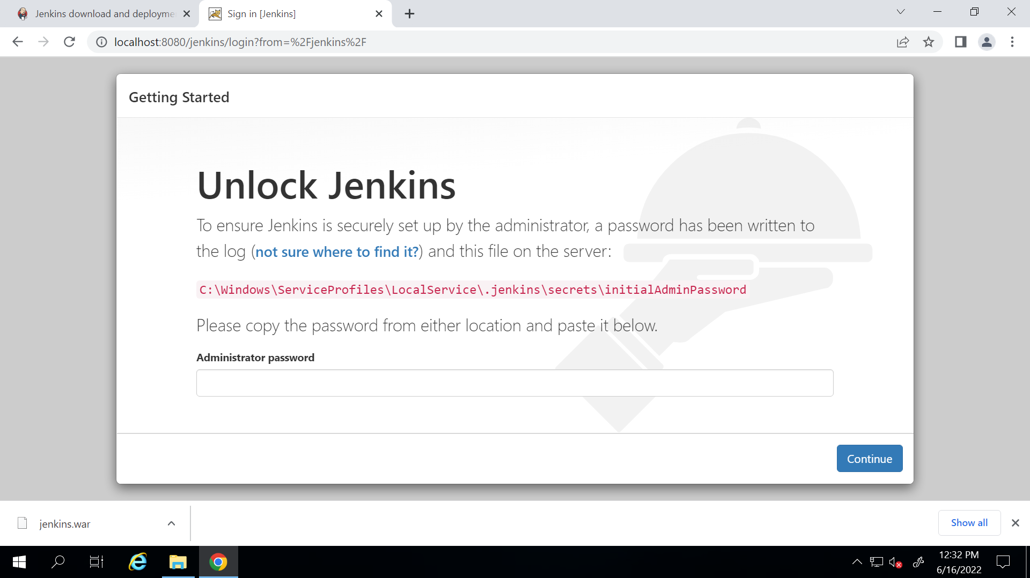

So first create a folder in C drive with name JENKINSHOME

Go to environment variables and create a new system variable as JAVA_HOME and give the path of JENKINSHOME

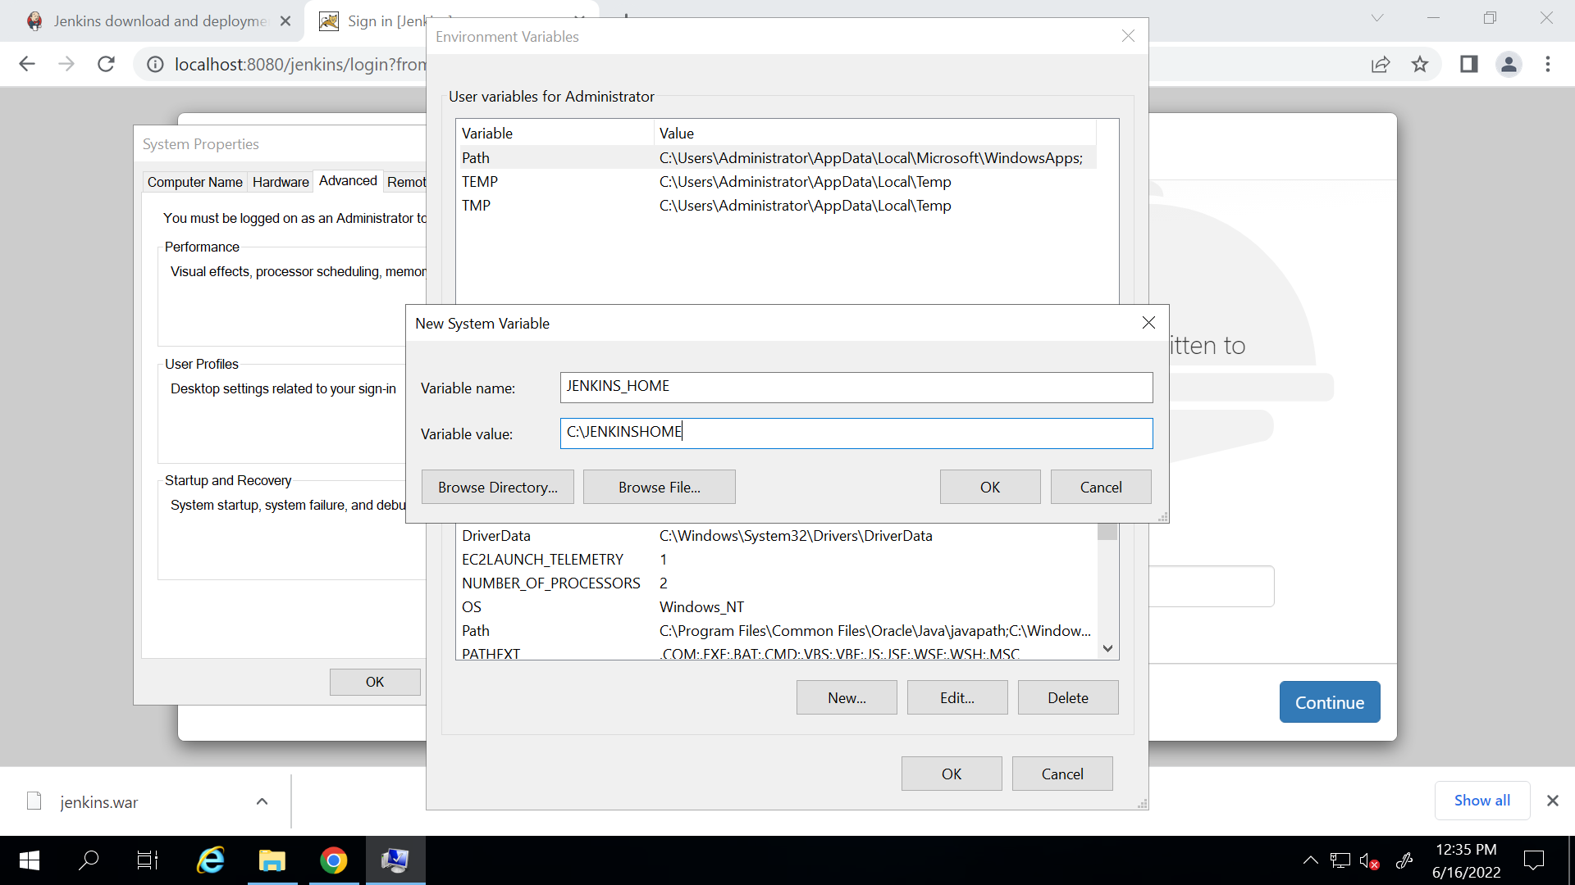

Now restart your system …..Reconnect with your machine again

1. Search for monitor tomcat and stop and start it

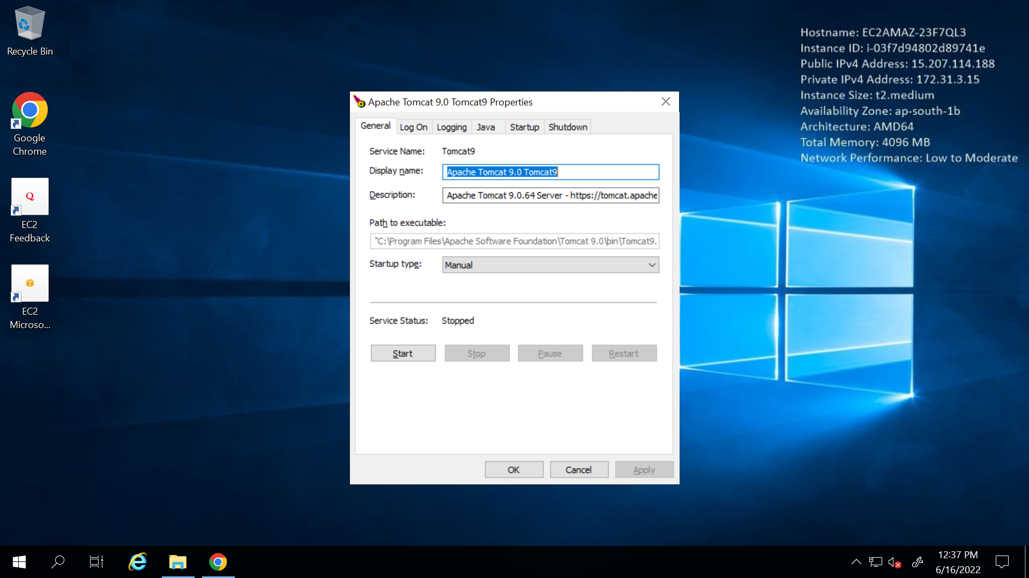

1. Go back to tomcat server…go to manager app…stop and start Jenkins… and then go to Jenkins

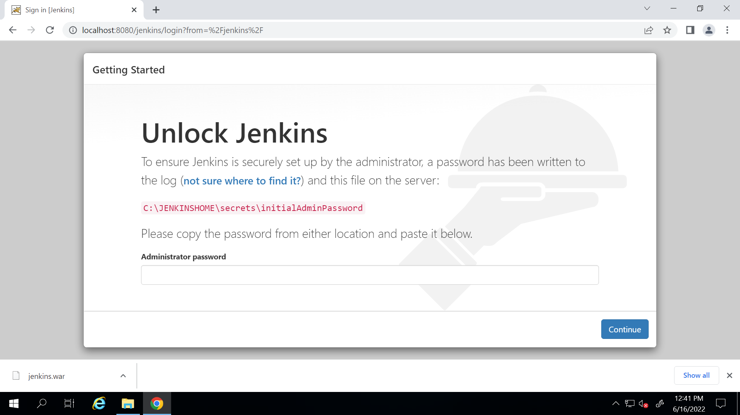

Now you see the link is changed to

C:\JENKINSHOME\secrets\initialAdminPassword

1. Put the password and unlock Jenkins …select plugins to install and click on none

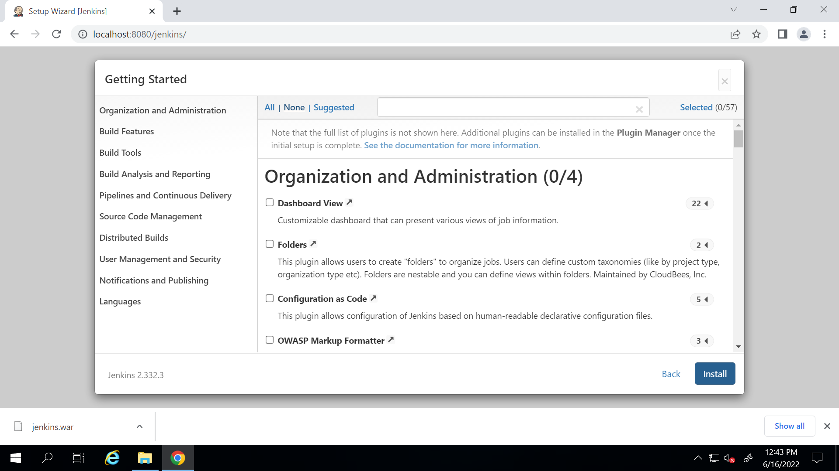

1. Put user name and pass

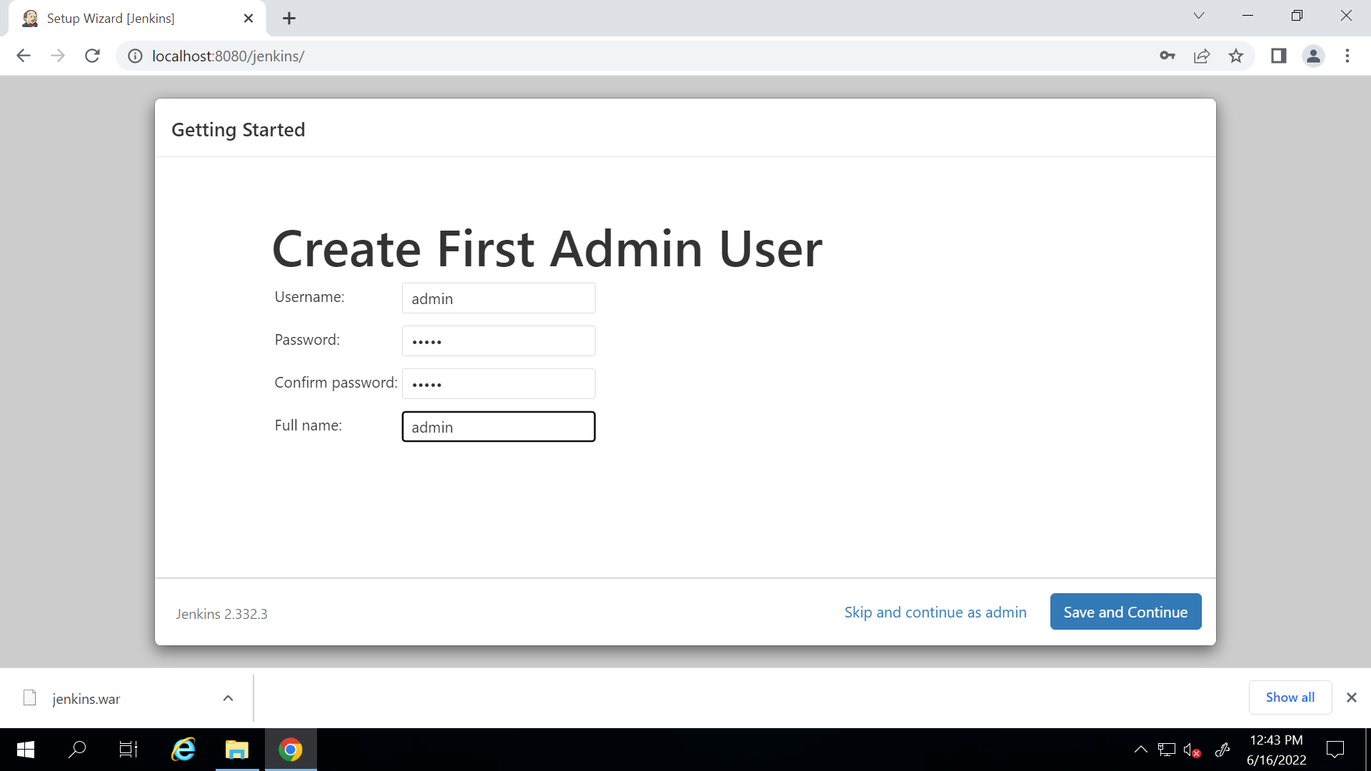

1. Download github plugin in jenkins

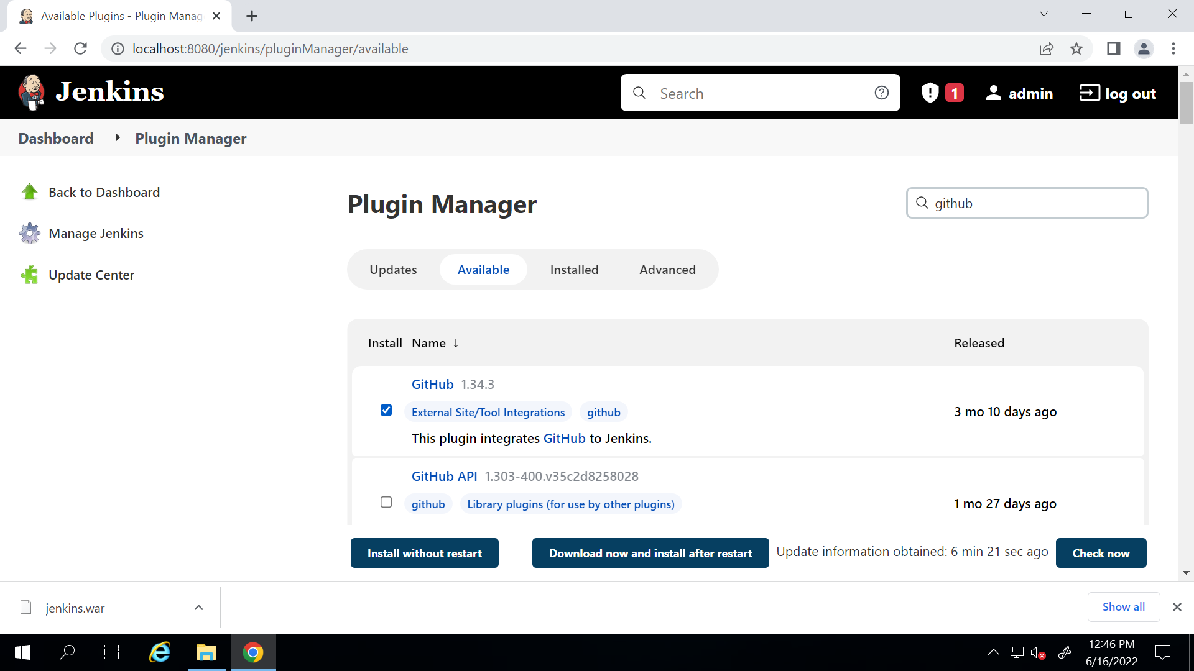

1. Create a new item ->

Codepull (freestyle project)

In configure in General tab click on advance and select use custom workspace

**${JENKINS_HOME}/workspace/projectdeploy**

(this will create a folder name workspace and under that projectdeploy and put all the deployment files in that)

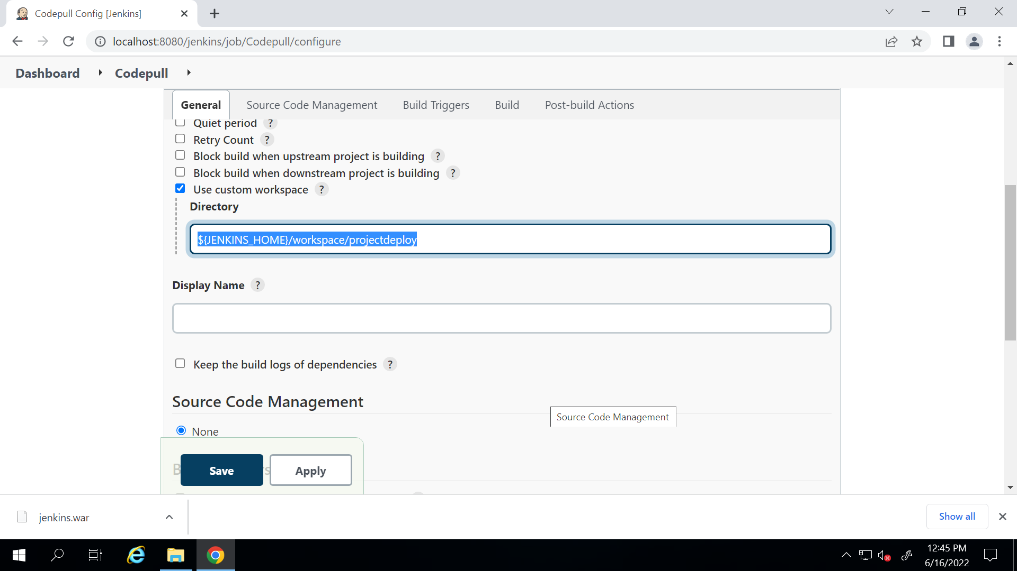

1. In source code management select github repo…click on save

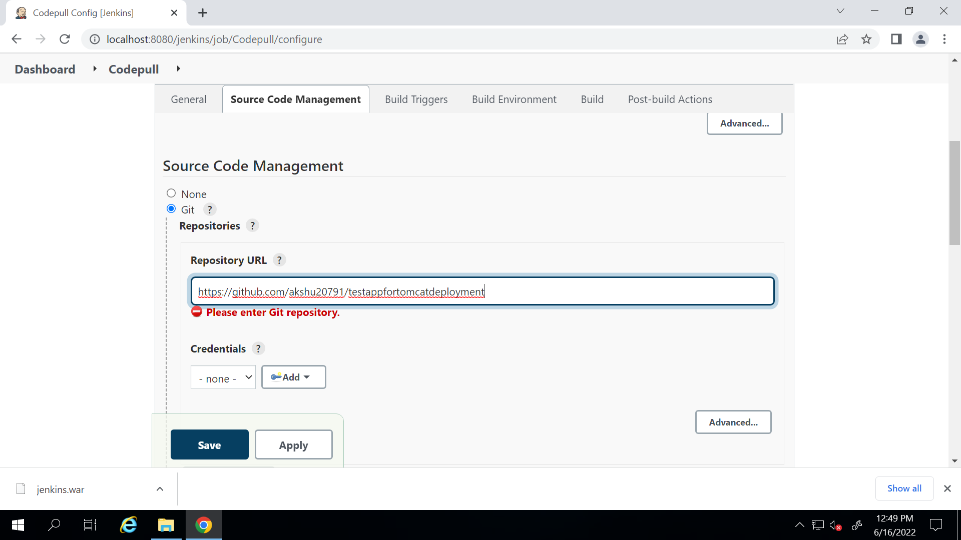

1. Go to plugins and install Ant plugin and Warning next gen plugin

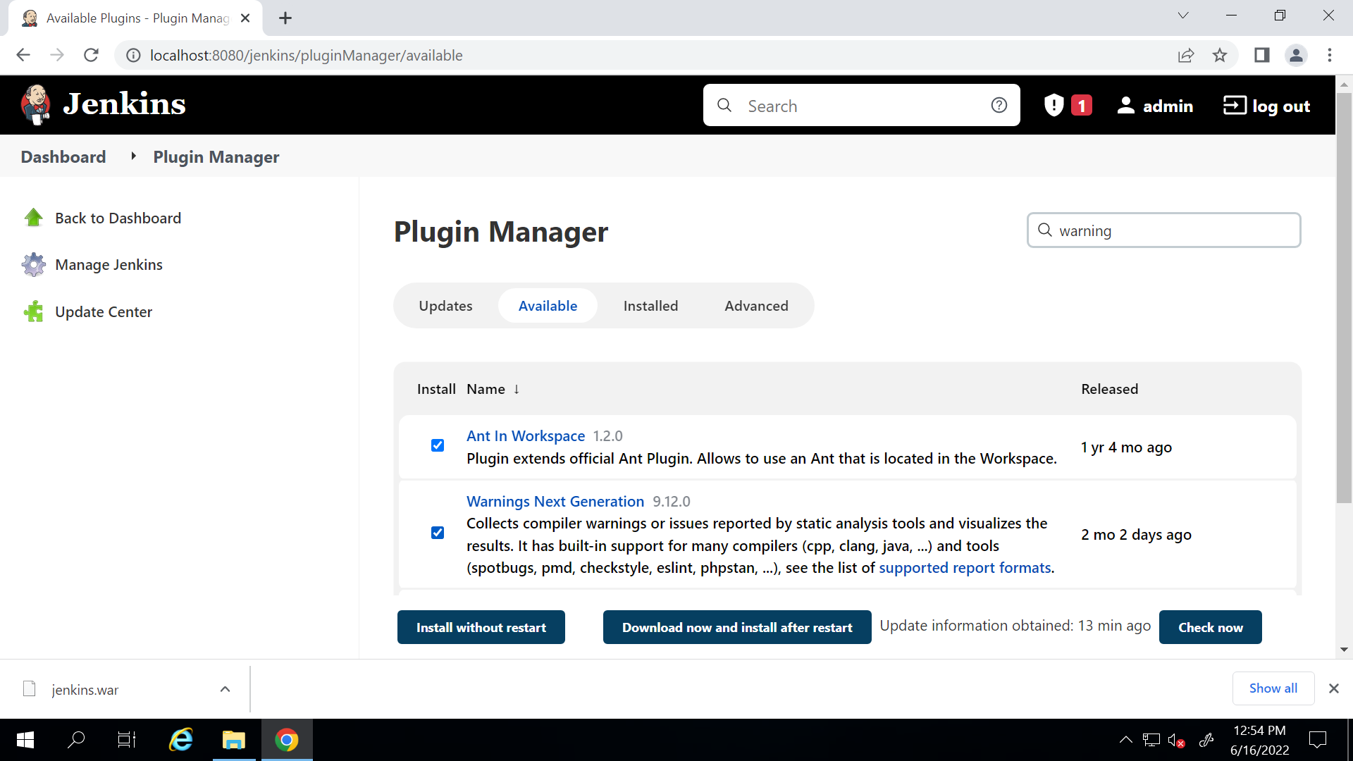

1. Create another item -> codecompileandreview

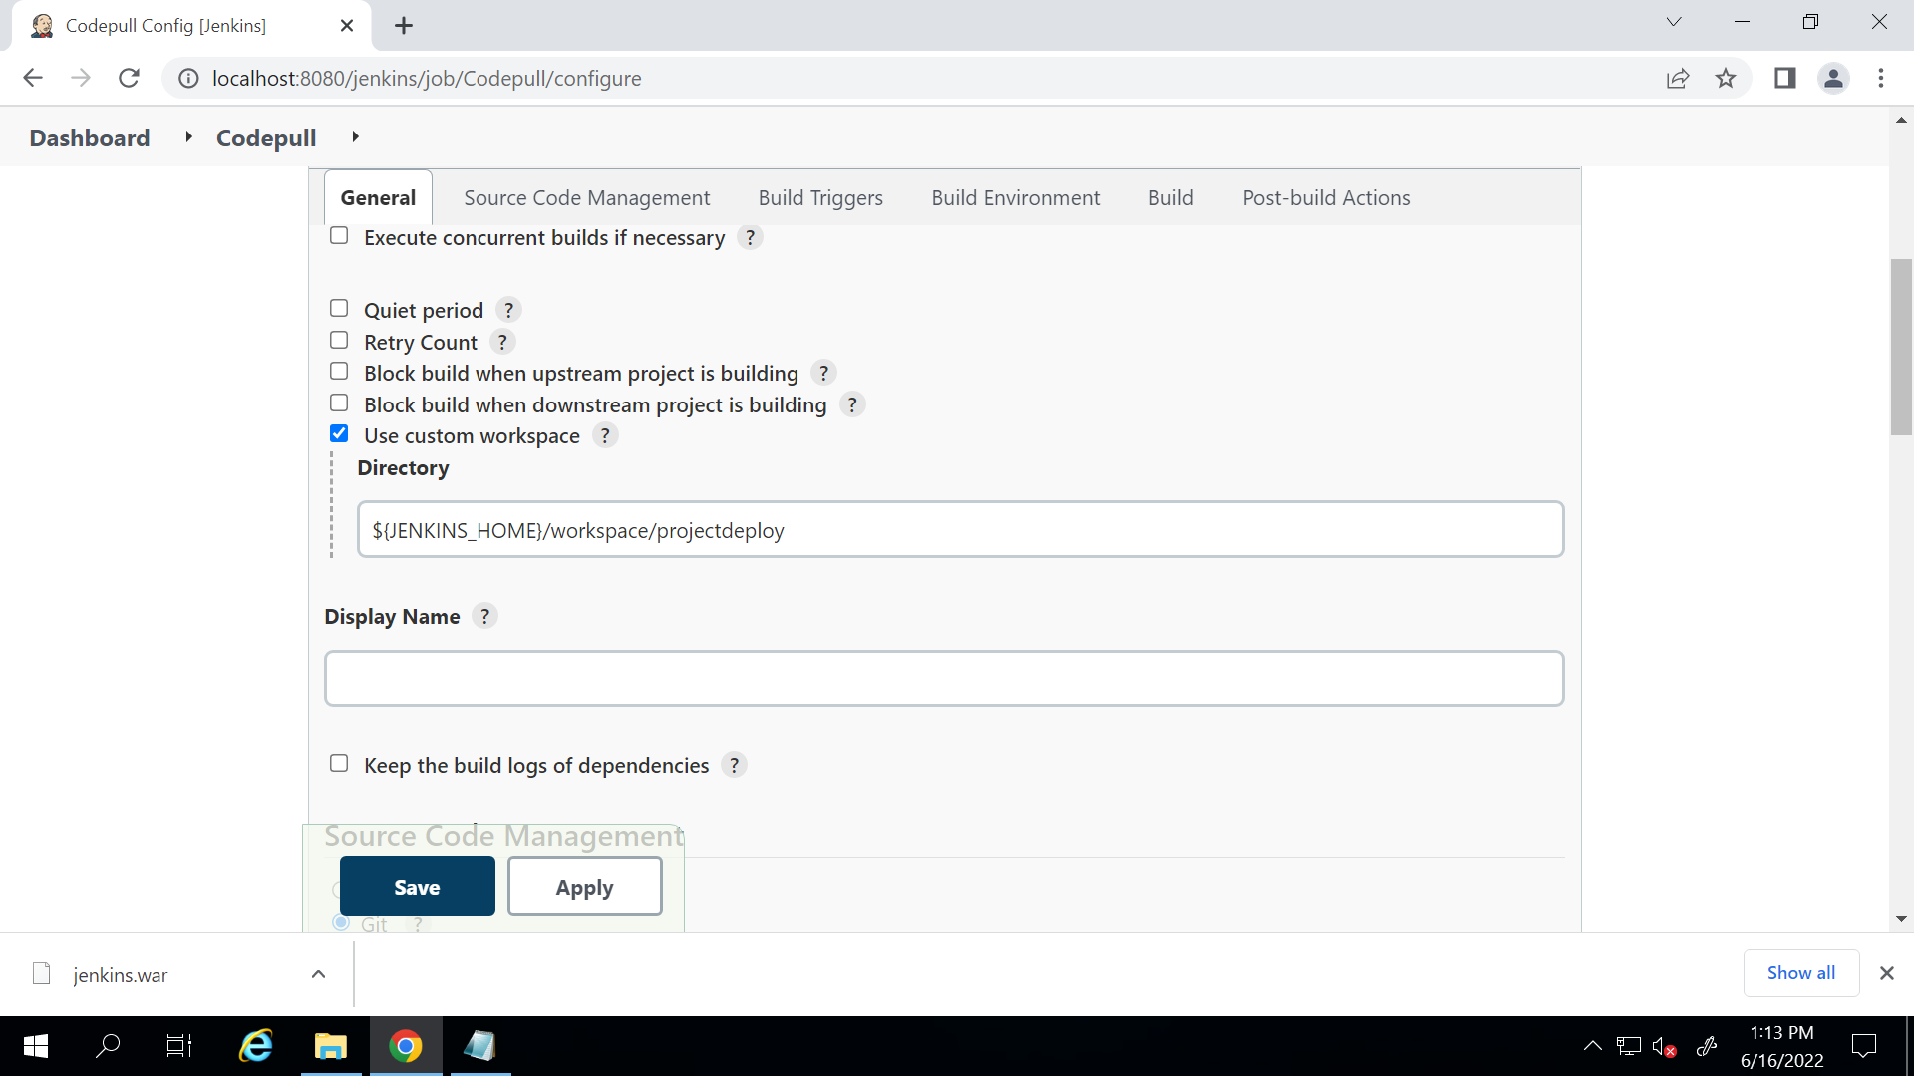

Put source code as git and put the link

Also in build -> invoke ant and keep target as blank

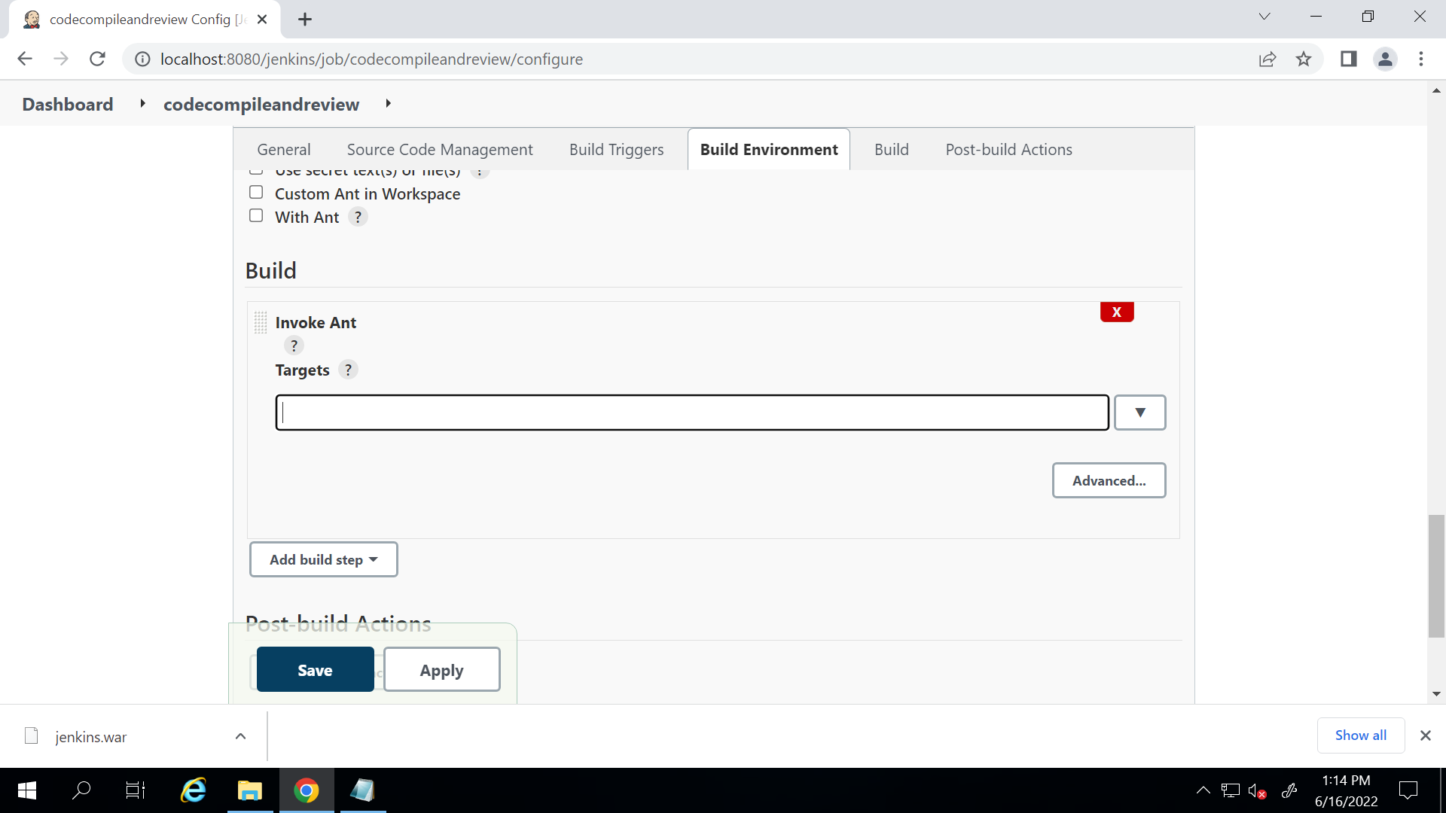

1. In post build steps -> record compiler warning and static code analysis result

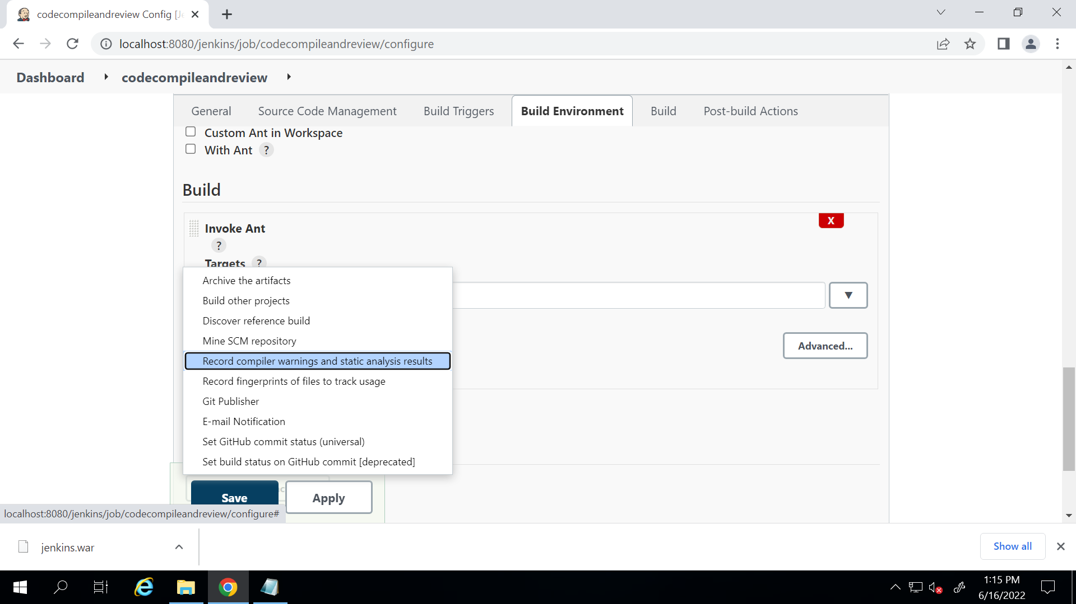

1. Put tool as checkstyle and report file as [checkstyle-result](https://github.com/akshu20791/testappfortomcatdeployment/blob/master/TestCalculator_JUnitResult.txt.txt).xml

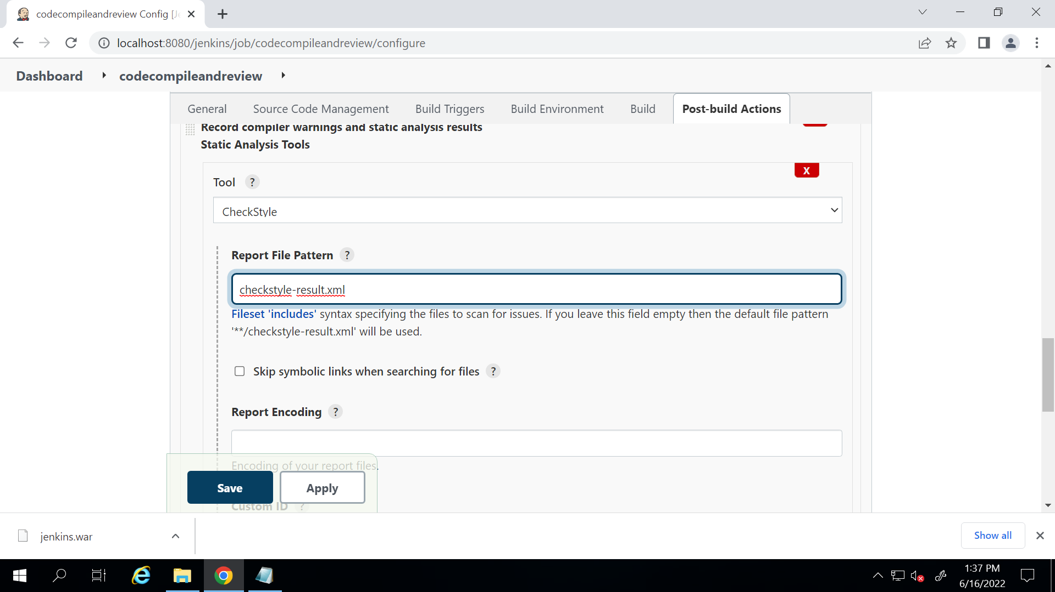

1. Go to manage Jenkins .-> add plugins -> install Junit plugin
2. Create one more project -> unittest (freestyle project)
3. General -> click on advance -> use custom workspace

Also put github repo link in source code management

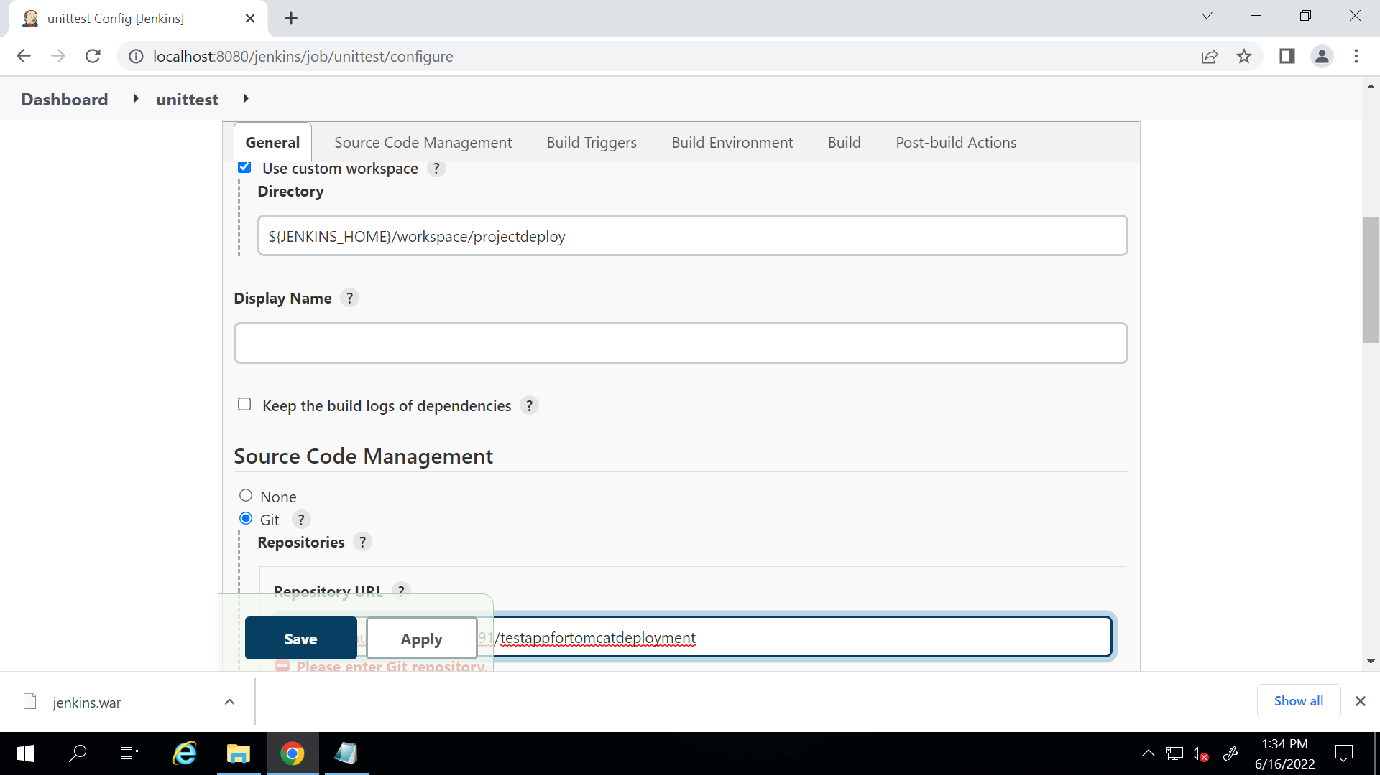

1. Build -> targets -> junit

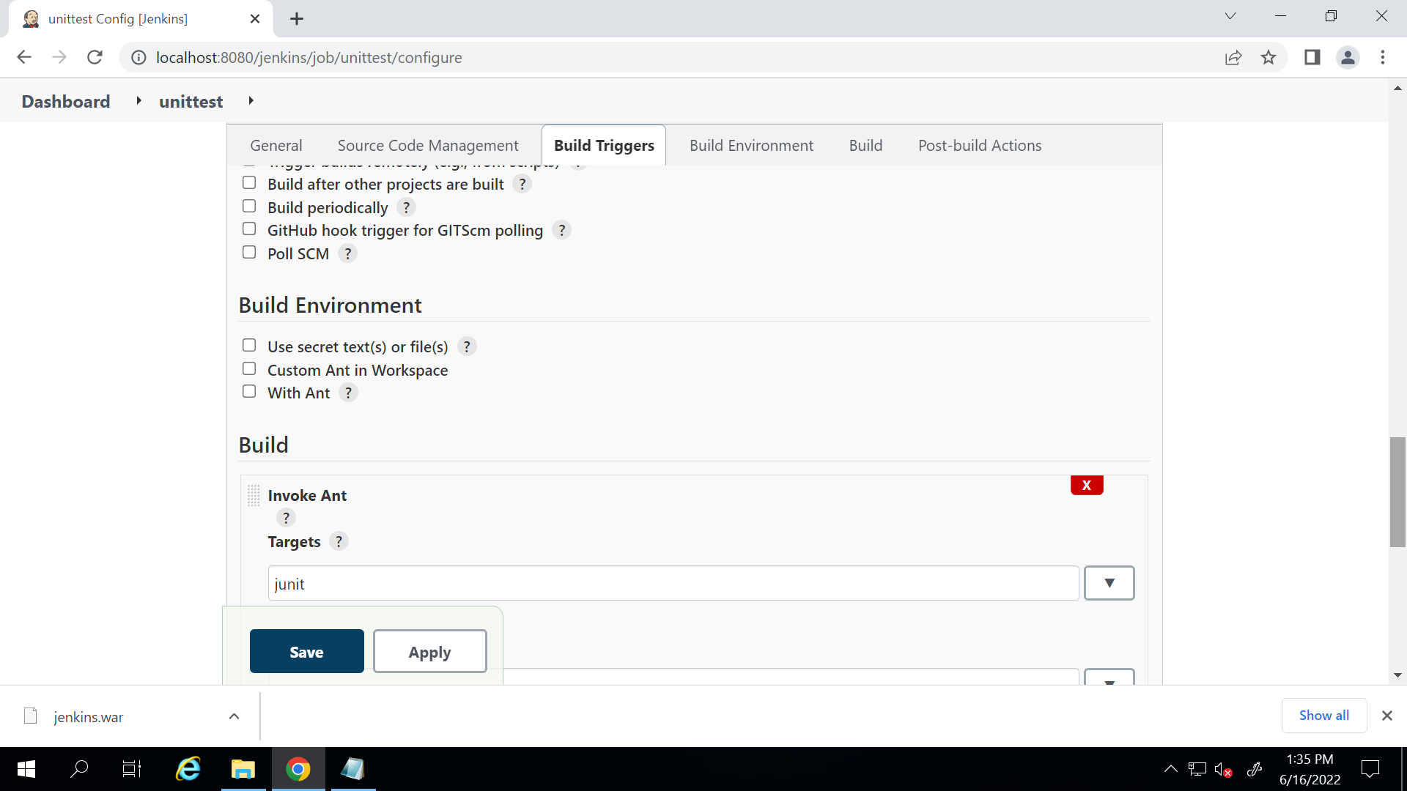

Add post build action -> publish junit test report

[TestCalculator_JUnitResult](https://github.com/akshu20791/testappfortomcatdeployment/blob/master/TestCalculator_JUnitResult.txt.txt).xml

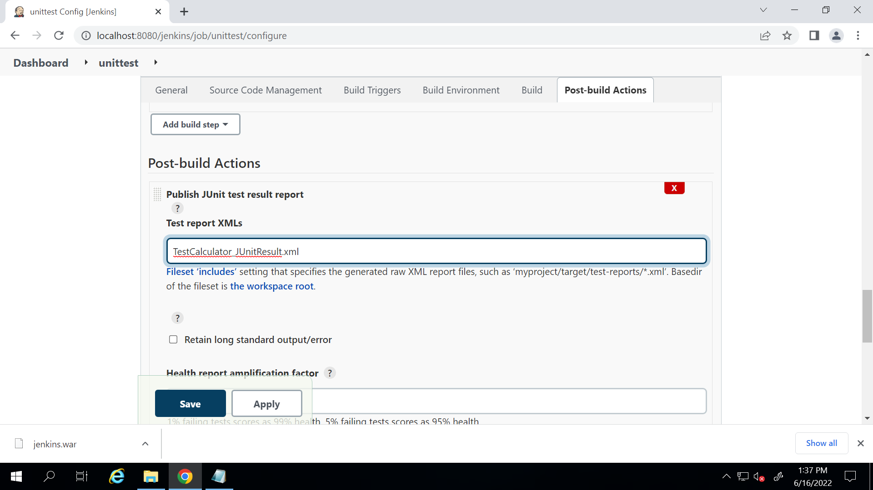

1. Go to plugins and install deploy to container plugin

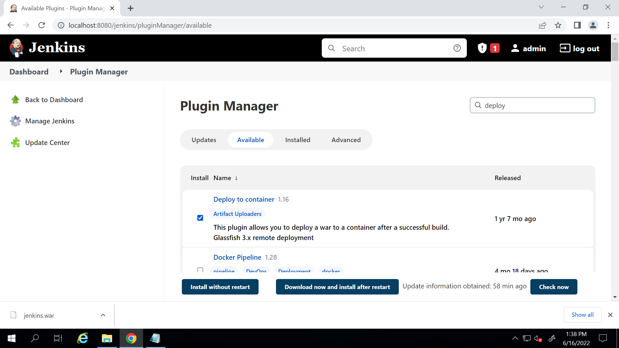

1. Create a new project - > deploy (freestyle) and add custom workspace as in image

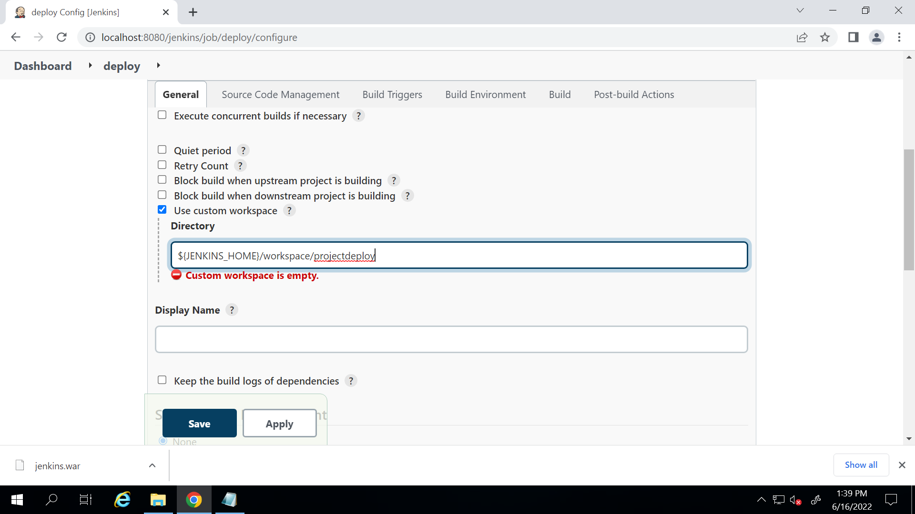

1. Put git repo link 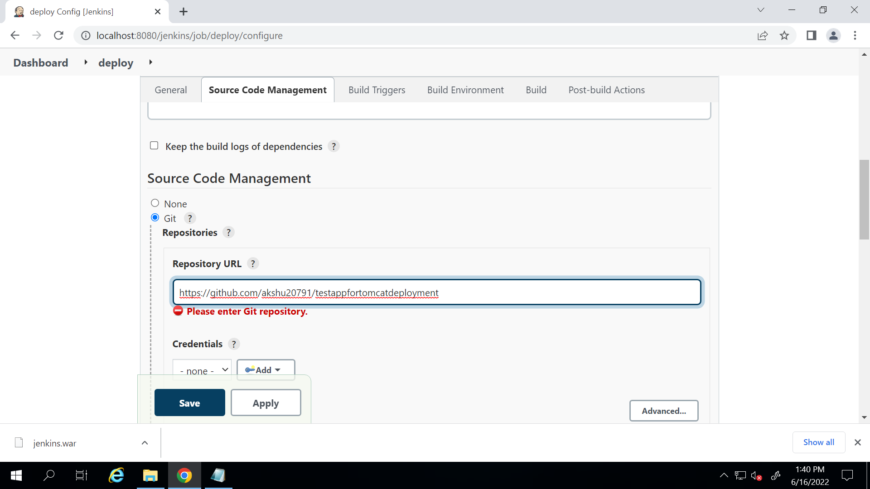
2. Go to build -> invoke ant -> target : war
3. Post build action -> Deploy war/ear to container

**/*.war

In context path: sampleapp

Container : Tomcat 9x remote

It will ask for credentials : select Jenkins in drop down

Select the credentials

Put Jenkins username and pass

Tomcat url : give http://localhost:8080 (or whatever url you are using)

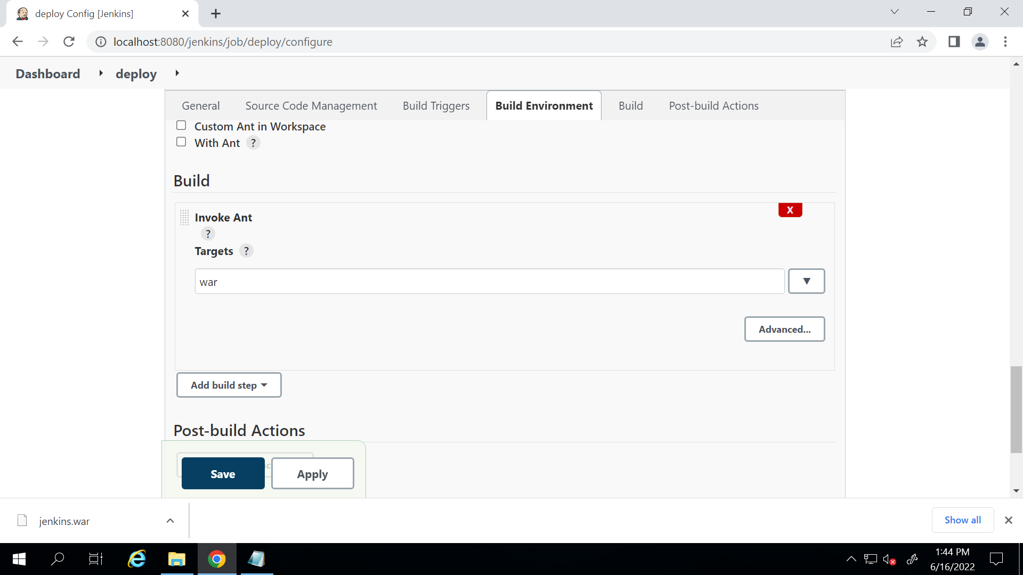

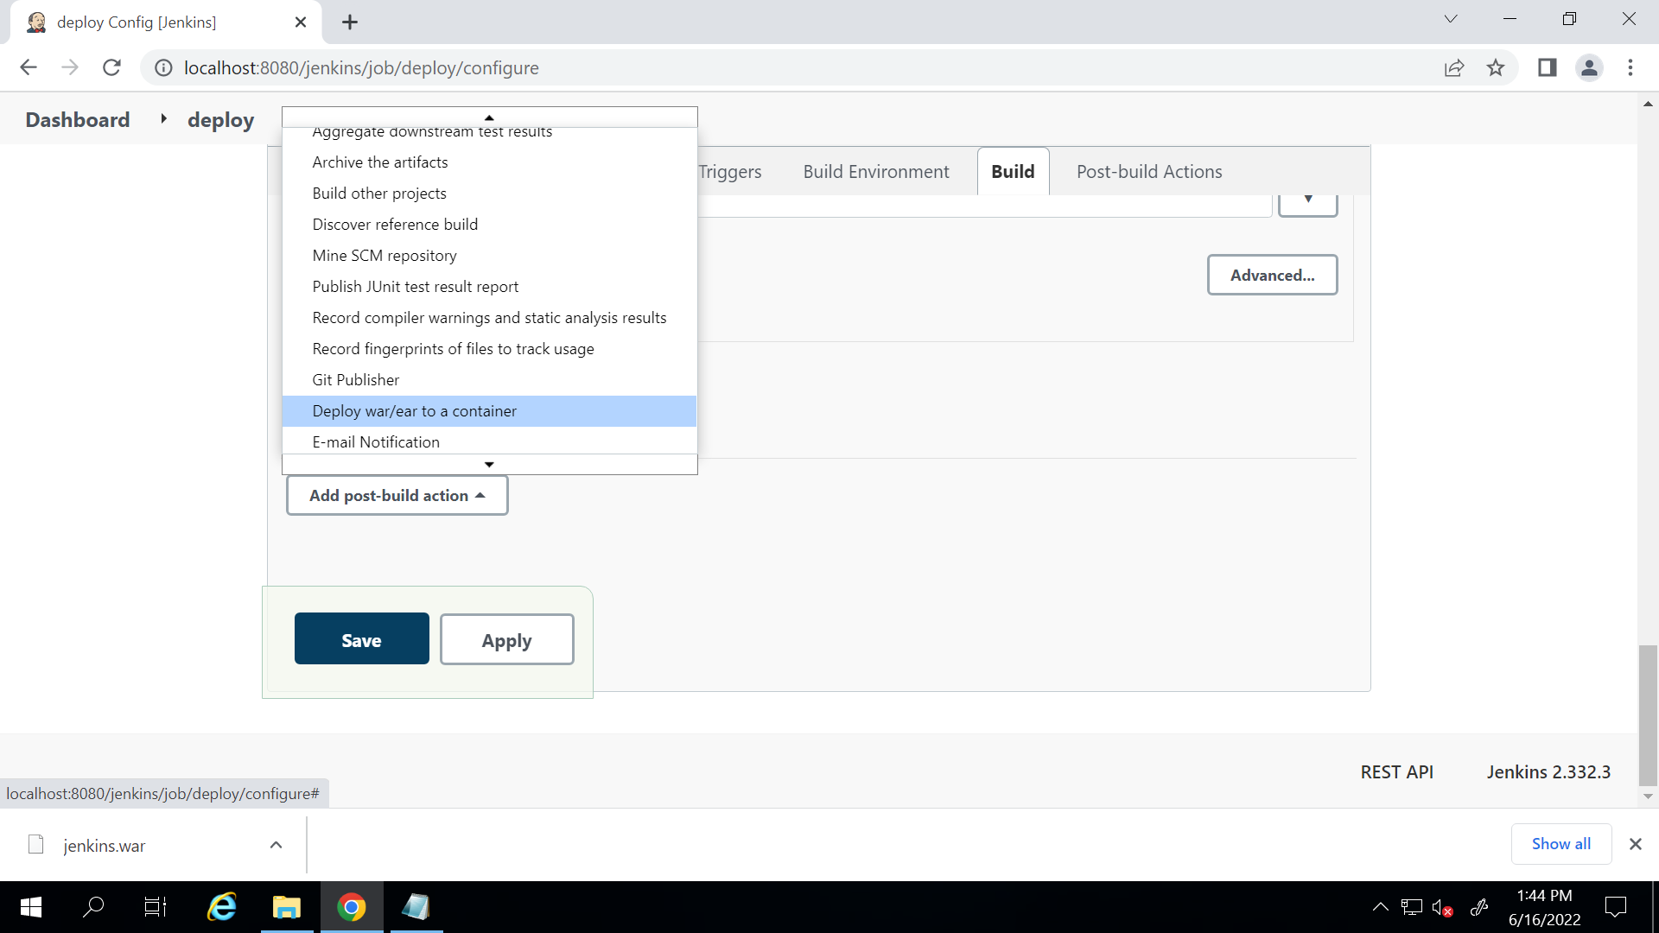

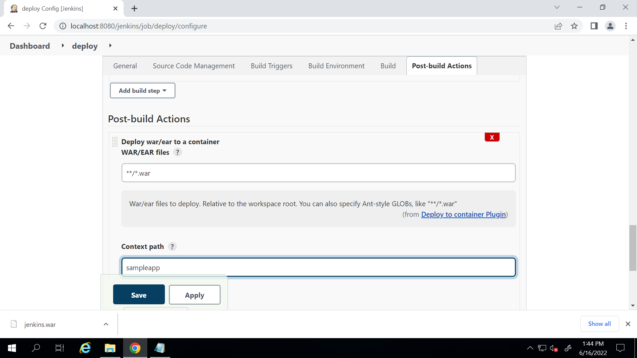

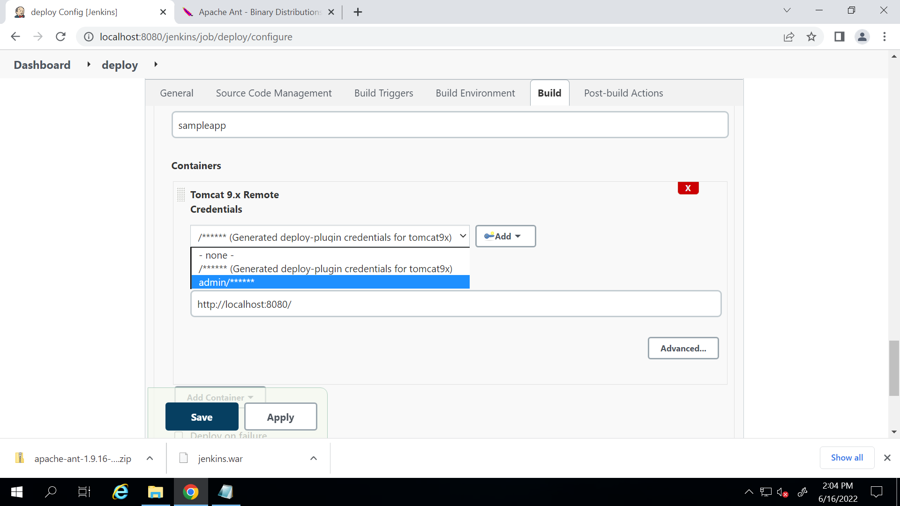

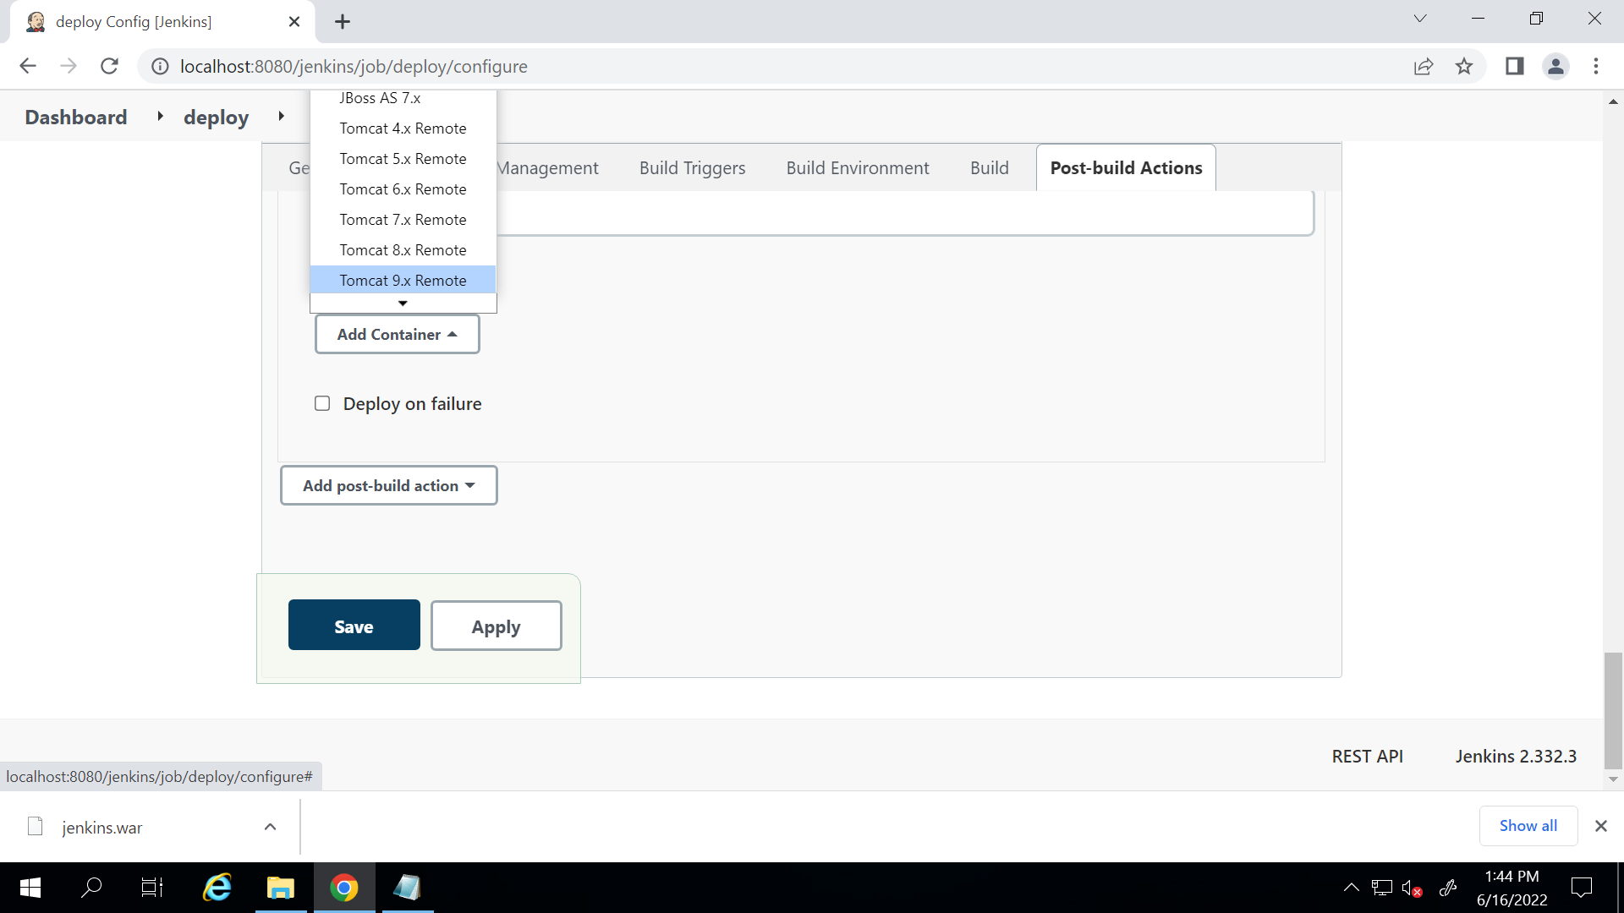

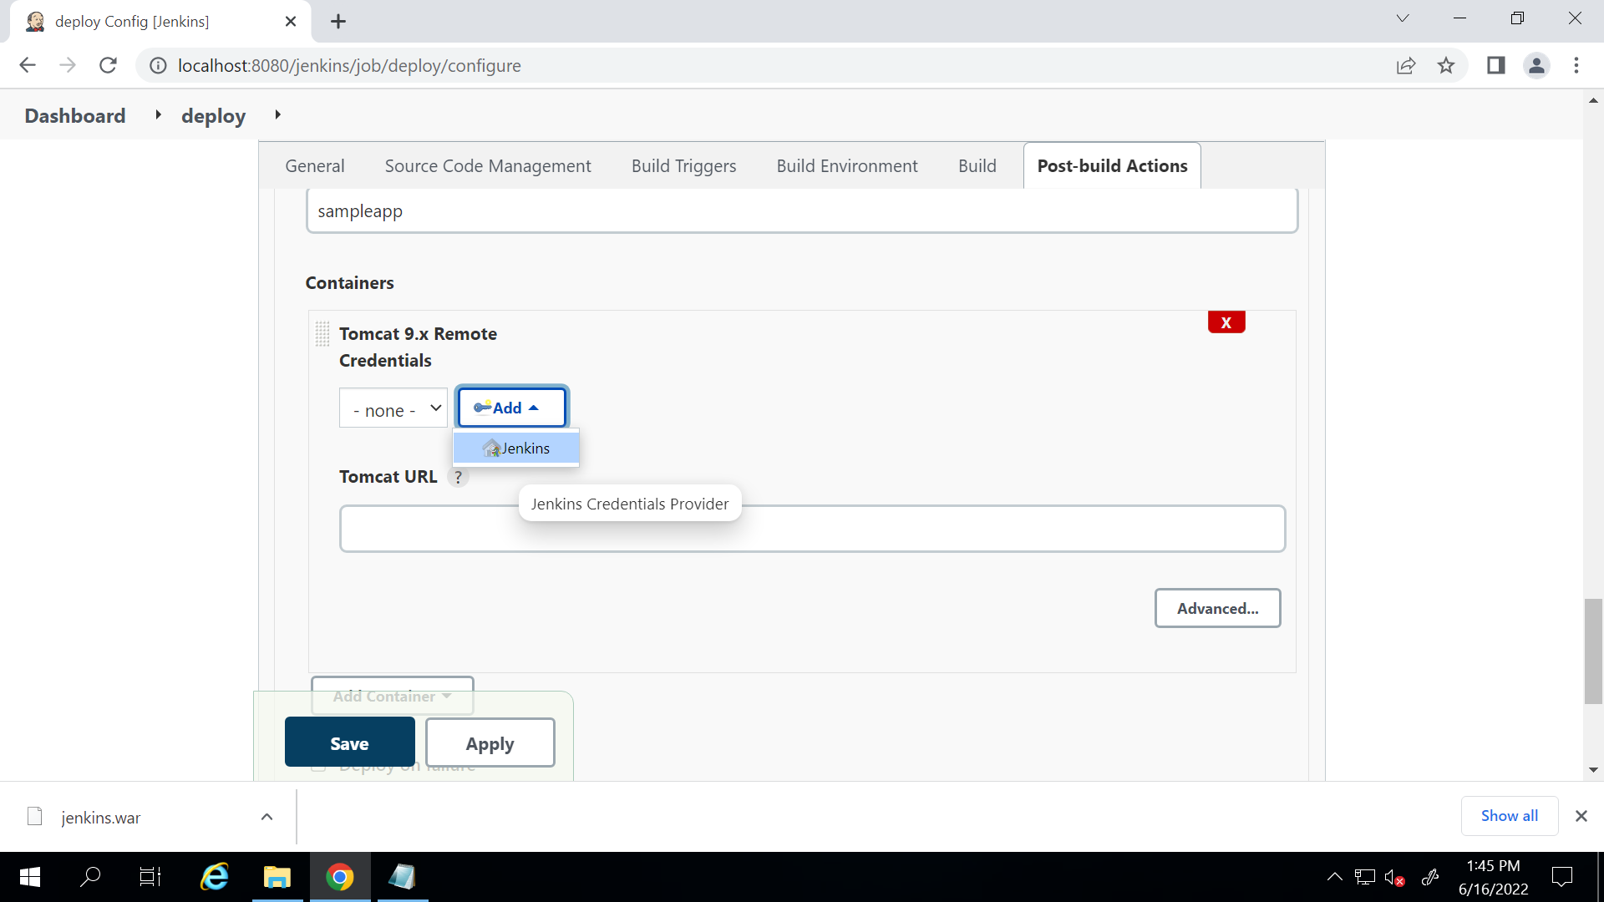

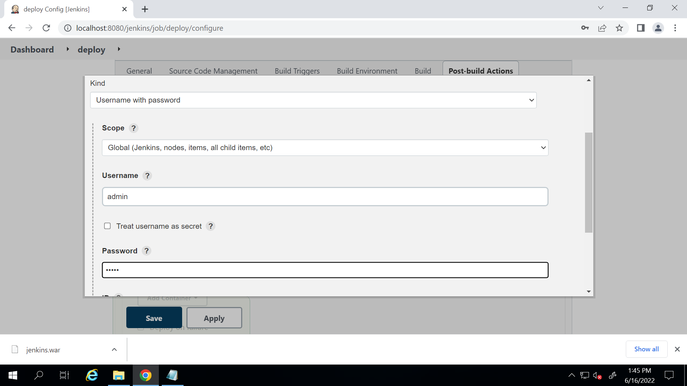

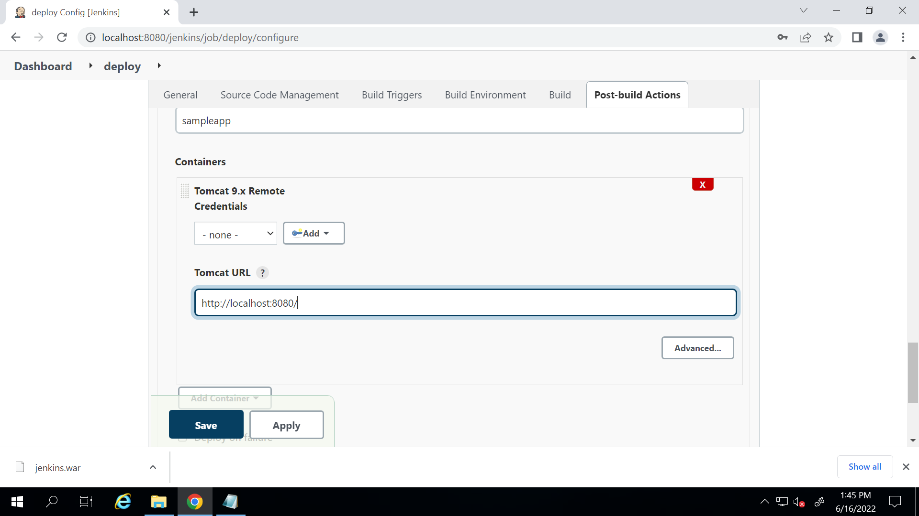

(make sure it is http)

1. Set upstream and downstream …so one by one all the jobs can be executed
2. Download the plugin build pipeline and create a pipeline
3. Go to C drive -> C:\Program Files\Apache Software Foundation\Tomcat 9.0\conf and open tomcat-users in notepad

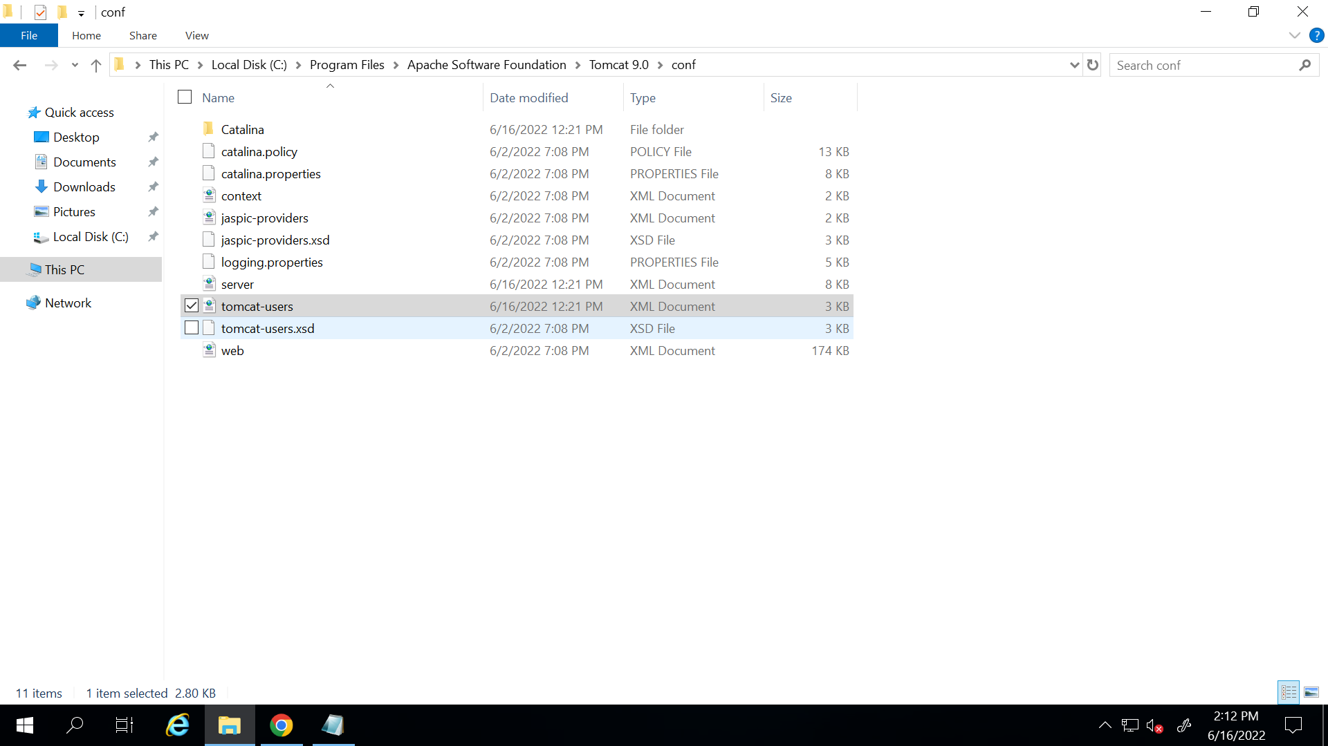

Now search for <user username="admin" password="admin" roles="manager-gui" />

Now search for the line 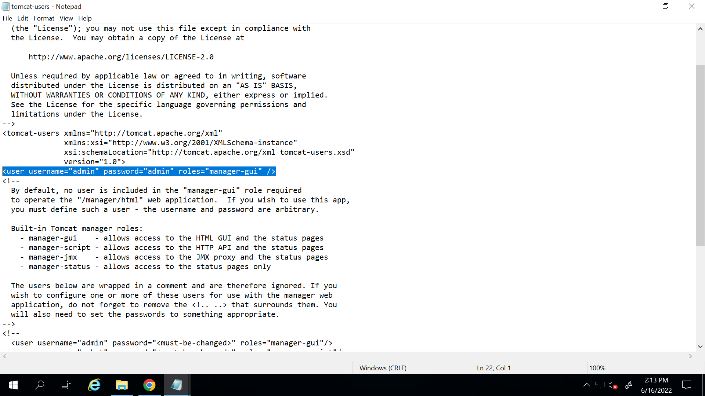

Add manager-script,admin after manager-gui

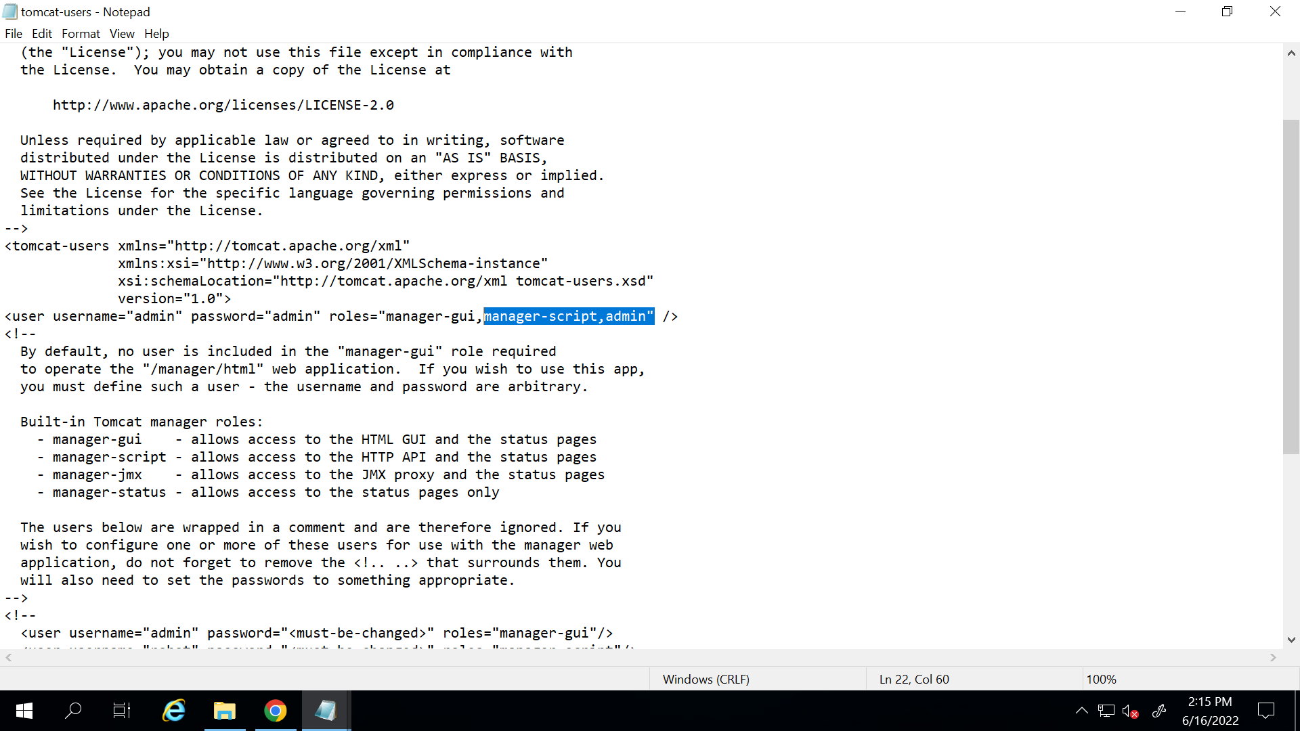

1. Search monitor tomcat and stop and start it again..also stop Jenkins and start again
2. Run the pipeline

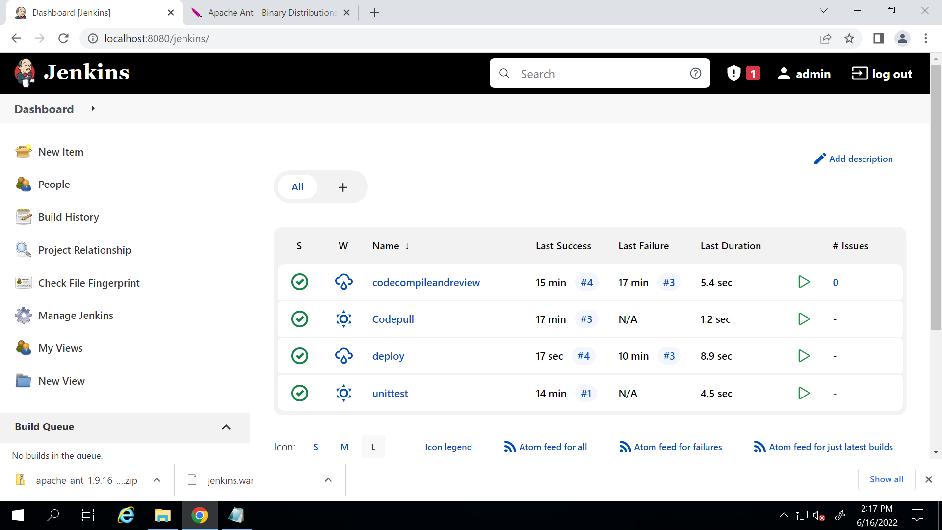

1. Go to tomcat ->manager app

You will see your app there

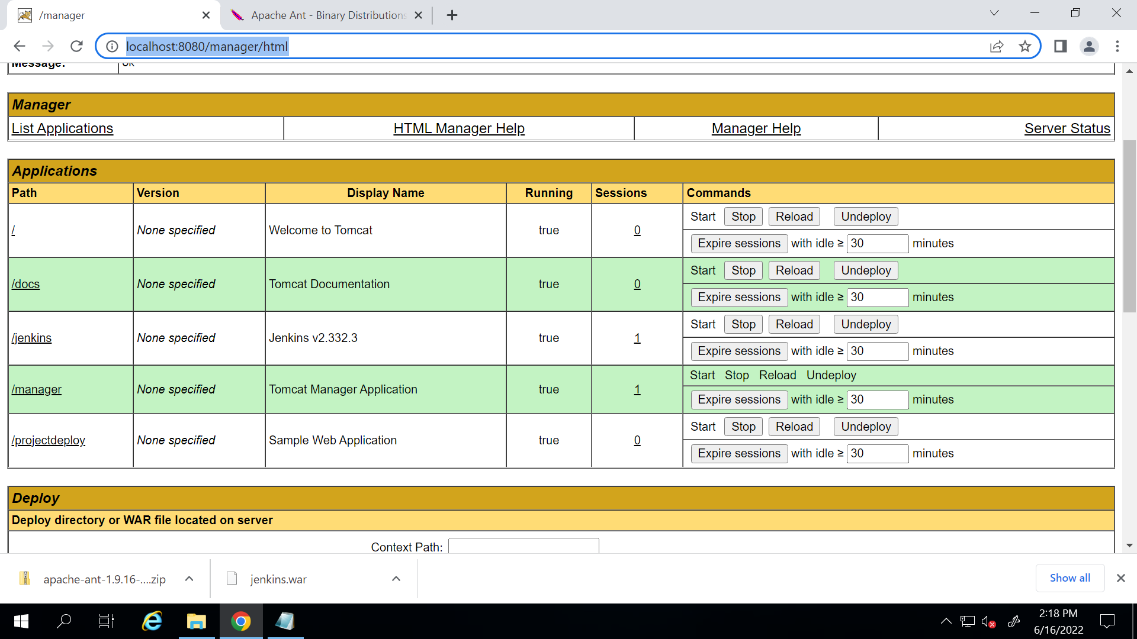

1. Click on it to open the website

